Jungle Safari Adventure Ideas

www.shac.org/jungle-theme
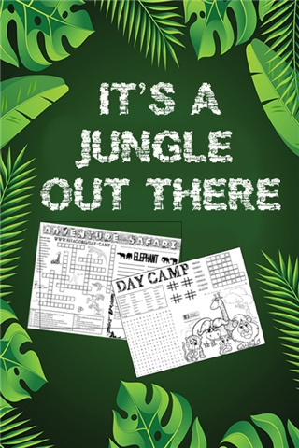

In 1914, Scouting founder Robert Baden-Powell started a Scouting program based on Rudyard Kipling’s The Jungle Book stories and targeted at younger boys in Britain. In 1914, Scouting founder Robert Baden-Powell started a Scouting program based on Rudyard Kipling’s The Jungle Book stories. Take the Cub Scouts on a safari and help them discover fun and adventure in the wilds of Scouting. Learn why Africa is special to our founder Lord Baden-Powell. Find out how the Jungle Book story connects to Scouting. Use it and its characters to highlight den meeting games, crafts, and costumes for the pack meeting. Learn about the things you need if you are going on a safari and how would you survive. What do Scouts in Africa do? What are their uniforms like? Take a den trip to a local zoo, animal rescue facility, or wildlife refuge.

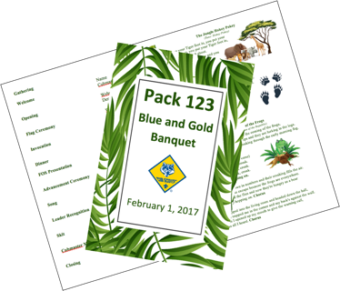
Jungle/safari makes a great theme for pack meetings, banquets or day camp.
- Pack Meetings: The pack meeting brings all the dens in the pack together for the purposes of recognizing the achievements of the Cub Scouts, communicating information about upcoming events, and providing a program that enriches the Cub Scouting experience. It helps the Cub Scouts realize their den is part of a larger organization. A good pack meeting should be well planned and well organized. Packs meet several times during the year – there is no required number.
- Banquets: Most packs celebrate Scouting Anniversary Week in February with a birthday party called the blue and gold banquet; some packs do end of the year banquets.

Resources: www.shac.org/pack-meetings
BSA Resources: www.scouting.org/programs/cub-scouts/pack-meeting-resources
Tips: https://blog.scoutingmagazine.org/2018/12/10/8-essential-tips-for-controlling-chaos-at-cub-scout-pack-or-den-meetings/

Content  (Sources: Baloo’s Bugle Oct 2002 It's a Jungle of Fun, Oct 2012 Jungle of Fun, 1998 Safari; Jungle Safari; BSA: Jungle of Fun Oct 2012)  Program Agenda  Podium Script  Cheers  Pack Meeting or Banquet Handout  Gathering Activities  Opening Ceremonies  Audience Participation  Invocations  Advancement Ceremonies (need)  Songs  Skits  Games  Closing Ceremonies  Cubmaster Minute  Theme Related Stuff | Blue and Gold Placemats  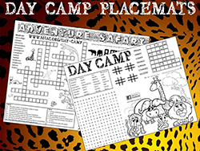  Free, customizable placemats are available for packs to use at blue and gold banquets and den leaders to use during den meetings to help promote day camp. Download placemats at  day-camp.shac.org/jungle-theme
Pinterest

Find additional ideas pinterest.com/samhoustonbsa/jungle-theme

Jungle/Safari Program Agenda

(for pack meetings or banquets)

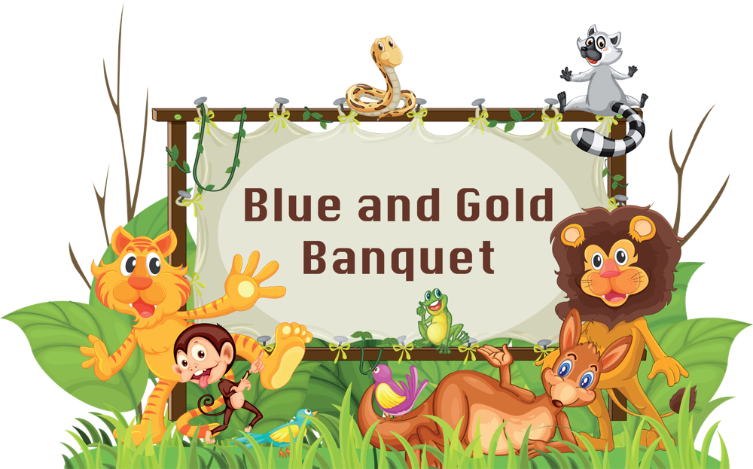
Welcome
CM: (wearing safari gear): Welcome the Cub Scouts, parents and leaders. Recognize special guests.
“In the earliest days of Scouting, the founder, Robert Baden-Powell, was overwhelmed with requests from younger kids and their parents so he decided to provide a program suitable. Baden-Powell knew that he had to find a theme for the program for younger kids so that it would be a program just for them and not a miniature version of the older program. In trying to come up with the program theme, he thought of Rudyard Kipling’s Jungle Books and knew that this was what was needed. Baden-Powell wrote to Rudyard Kipling and asked permission to use his books as the basis for the younger youth program. Kipling, a solid supporter of Scouting, the father of a Scout, and the author of the official Scout song gave his permission. From this come the roots of Cub Scouting around the world. Tonight, as we have our fun and celebrate the work our Cub Scouts have done, let’s remember our jungle roots. Now let’s get the meeting into full swing and have some fun as we monkey around!”

Opening Pre-select a den to lead the opening ceremony and have the den leader practice with the Cub Scouts for several meetings prior. Find additional opening ceremonies here.
Setting – 8 Cub Scouts in a line; six should be holding the letters S-A-F-A-R-I with the appropriate verses on the back. Use poster board and make the letters our of sticks or fake leaves.
Scene – Cub Scouts stand in a line spelling SAFARI. One Cub Scout without a letter stands on each side of this line.

Hint- have the den practice multiple times before the banquet. Teach the Cub Scouts to talk slow, look up at the adience and how to talk into the microphone or talk loud project their voice to the back of the room. Write the words on the back of the posters, but make sure Cub Scouts don’t talk down when reading.
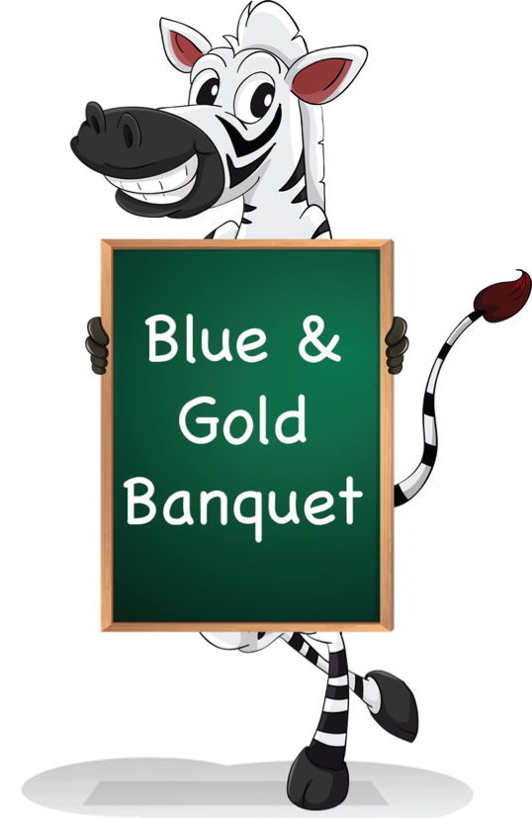
#1: Jungle Safari is our theme for the blue and gold banquet. Safari means searching, and we are searching for some fun!
#2: S is for Scouting; we’re searching the trail. For adventure and fun, we surely can’t fail.
#3: A is for Action; we like to play games. But being good sports is part of the aim.
#4: F is for Fun, we like being Cub Scouts! It’s the best thing there is, without any doubt.
#5: A is for Adventure, and trying new things. We give it our best when we try anything.
#6: R is for Ready, we’re ready to go! On field trips, or camping, or the yearly Scout Fair.
#7: I is for Ideals, that we learn here in Cub Scouts. Of loyalty, country, and freedom we shout.
#8: Please join us in saluting our country’s symbol of freedom by saying the Pledge of Allegiance.

Pledge Pre-select a den to lead the plege and have the den leader practice with the Cub Scouts for several meetings prior. Can be same den that does opening.

Invocation (if food is served). Find additional invocations here.

We approach Thee, and ask Thee to join Thy love for the Cub Scouts. Give us the vision to see our duty and the courage to perform it. Teach us to walk together in the spirit of brotherhood, so that we are true to Thee. Fill our hearts with appreciation, and respect for all living things, those that live in the waters, and those that crawl upon the land. so that we might live together in harmony and in peace. Help us to obey the Scout Oath and Scout Law. Our dear Heavenly Father, we ask a special blessing on the families in our Cub Scout pack. We ask a special blessing on each Lion, Tiger, Cub Scout, and Webelos Scout as they give service to other people. Guide their steps as they grow into men, and help them as they do their duty to You and our country. Bless our food and the people who have prepared it. Amen

Dinner (for banquets)

Friends of Scouting (FOS) Presentation (usually at banquets or a big meeting between Jan to May)
Special Program / Guest (for banquet)

Advancement Ceremony: Jungle Tour
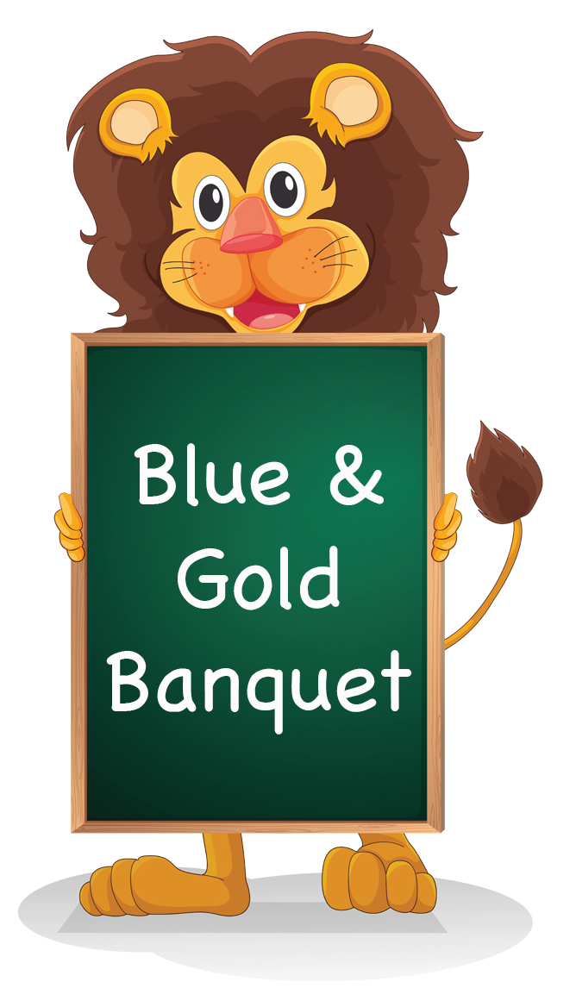
Equipment: Sound effects of a car or truck motor, prerecorded wild animal noises, Cubmaster dressed in safari attire. Recording of motor will be turned on and off at designated places, while the animal recording can run continuously after the tour has started.
Cubmaster: Ladies and gentlemen, welcome aboard our Cub Scout Jungle Tour Bus. I hope you have all signed the waivers that would free our pack of any responsibility for accidents or unexpected dangers. It’s a jungle out there, you know. Please remain seated at all times with your seatbelts securely fastened. Please keep your hands and feet inside the bus at all times and DON’T feed the animals, no matter how much they beg. Now, let’s begin our tour. (Start the motor recording and the animal noise, and play both softly in the background.)
On your left, we will be coming to the watering hold of the Lions. They have done much to get themselves this far along the trail. They have learned how to be a good Cub Scout. (Stop the motor recording and hand out any Lion awards. When finished, start the motor recording again.)
Now, we come to our prowling Tigers. (The Tiger den leaders come forward to help hand out awards. Hand out the Tiger awards to parents to present to their sons. Lead a cheer. Start recording again.)
Next, we come to the Wolf den. (The Wolf den leaders come forward to help hand out awards.) Mother/Father Wolf has nurtured his/her little cubs until they are strong enough to work on their own in some things. They have learned many new things as they worked on important lessons that teach them how to be good Wolves. (Stop the motor recording and hand out the Wolf awards to parents to present to their sons.. Lead a cheer. Start recording again.)
Over here on our right is the feeding ground of the Bears. Be careful, they are always hungry and will beg for food with long suffering faces. But Baloo, their teacher, has taught them the Scout Law. (Bear den leaders come forward to assist.) Baloo has grown wise and finds that if he makes the Bears work a little on their own, they can accomplish much—even without food. (Stop motor recording and hand out Bear awards to parents to present to their sons. Lead a cheer. Start recording again.)
Looking out on the plains ahead of us, you can see a herd of wild Webelos. They may appear to be grazing lazily, but with a little motivation, they can create a stampede of activity, working together to achieve much. Their leader can really call them to action as they do new and exciting things each month. (Webelos leaders come forward to help hand out awards. Stop motor recording and present the Webelos awards to parents to present to their sons. Lead a cheer. Start recording again.)
This concludes our tour of the Cub Scout Jungle. We have made it safely back to our blue and gold banquet. Thanks for helping to make this tour such a success; we appreciate your support of our pack. (One final cheer for all!!)
More Advancement Ideas
- Make a palm tree from a carpet tube and green butcher paper. Stick in a paint bucket filled with rocks. Wrap a paper snake around the tree. Attach awards to little cutouts of snakes on which you write, "You are such a sssss-super Sssss-scout, You'll go down in Hissssstory. Congratulations on earning your....
- Attach awards to different jungle animals pictures. Display around room. Call on Scouts who are receiving awards to pick one of the animals. Call that Cub Scout up to get their award.
- Put awards in a box. Dress in a safari costume. Have two leaders carry in the large box suspended from two long poles.
- Crocodile- Put crocodiles in a wading pool. The Cub Scout retrieves their crock with their award inside. (Use green plastic soda bottles decorate.)
- Attach awards to bananas. Display bananas on a large poster of a gorilla or better yet, have someone come in dressed as a gorilla. carry awards in containers made to look like bananas!

Song Pre-select a den to lead a song in the meeting handout. Additional songs can be found here.

Leader Recognition
Materials – pretend binoculars mounted on a display with the words – "Thanks for bringing adventure to our pack with your remarkable views."
CC - Every month at our pack meetings, we recognize the Cub Scouts who have received awards. Today, we would like to recognize our leaders. Call up all den leaders and committee members..

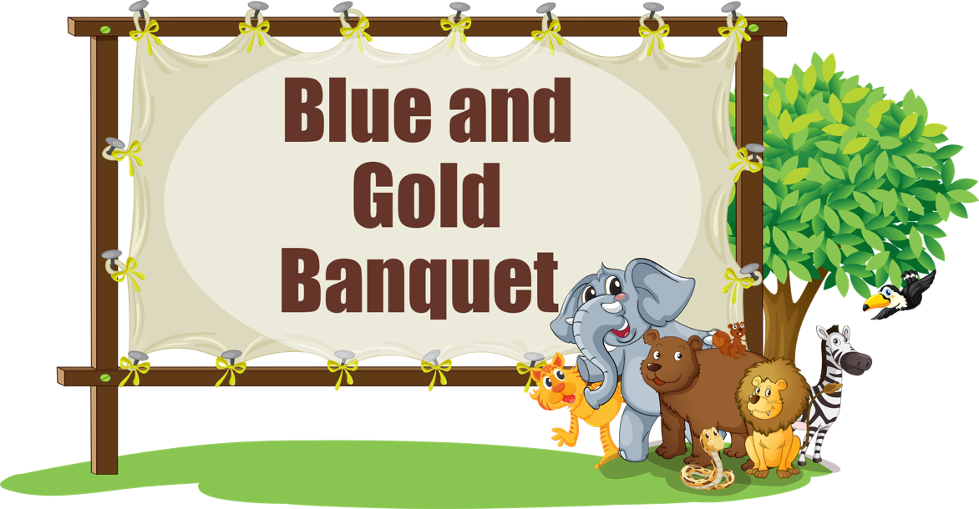
There are eyes upon you and they're watching night and day.
There are ears that quickly take in every word you say.
There are hands all eager to do anything you do,
And youth who are dreaming they can be a leader, too.
You're a Cub Scout’s idol. You're one of the very best.
In their minds, you’re somehow better than the rest.
They believe in you devoutly, and in everything you do,
They are waiting for the chance to act just like you.
There's an energetic kid who believes you're always right.
And their ears are always open; and they watch day and night.
You are setting an example every day in all you do,
For a Cub Scout who's waiting to grow up to be like you.
Conduct a cheer.
CM – We have some leaders and parents with us tonight who have forged a path for our pack through the jungle of training and planning and we would like to thank them for taking the time to make sure they are presenting you Cubs with the very best program. We have the binocular award for them – for always keeping a close eye out for opportunities. Present any leader training awards.

Audience Participation (optional). Find additional Audience Participation skits here.

Game (optional). Select a game. These can be good only if the pack meeting doesn’t run too long.

Skits (optional). Have a den leader select a skit and practice for several meetings prior.

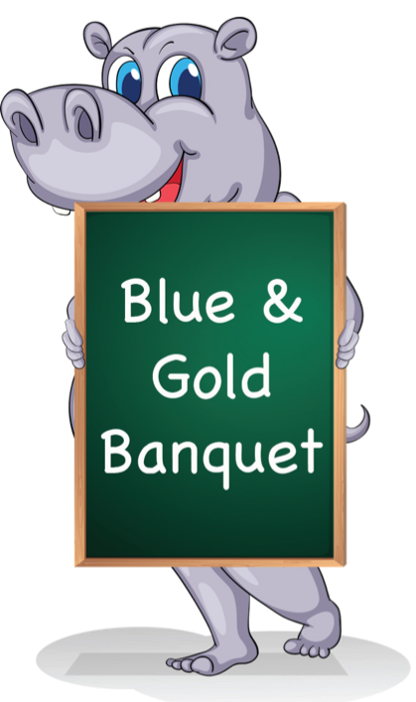
Den conducts a skit. Assistant Cubmaster then conducts a cheer. Hint:have the den practice multiple times before the banquet. Teach the Cub Scouts to talk slow, look up at the adience and how to talk into the microphone or talk loud project their voice to the back of the room.

Cubmater Minute. Find additional Cubmaster Minutes here.
We would like to recognize and thank the blue and gold banquet committee members for their effort and hard work. Wow! What an exciting adventure we had tonight with our Jungle Safari. We met some pretty interesting characters along our trek and we congratulated a lot of Scouts for their awards. Scouting can be a real adventure, whether or not we’re in the jungle. Lord Baden-Powell called Scouting, “fun with a purpose.” There is a definite purpose to the awards our Scouts are earning. They are learning new skills and developing a sense of character so that when they enter the real jungle of being grown up, they will be prepared. I, for one, am very proud of their accomplishments and I hope they are proud, too, and will continue along the safari trail of Scouting.

Closing. Pre-select a den to lead the closing ceremony and have the den leader practice with the Scouts for several meetings prior. Can be same den that does opening/pledge. Find additional closing ceremonies here.
Setting: Six Cub Scouts each with one letter from S-A-F-A-R-I (If you used the SAFARI opening, recycle the letters)
#1: S is for Scouting spirit
#2: A is for Aims and Methods
#3: F is for Friends and making memories
#4: A is for Awards and advancing on the Scouting trail
#5: R is for Really fun Scouting activities
#6: I is for I had a great time tonight!
All: Thanks for coming to the blue and gold banquet and good night!
Podium Script: Welcome

Cubmaster (wearing safari gear): Welcome the Cub Scouts, parents and leaders. Recognize special guests. In the earliest days of Scouting, the founder, Robert Baden-Powell, was overwhelmed with requests from younger kids and their parents so he decided to provide a program suitable.

Baden-Powell knew that he had to find a theme for the program for younger kids so that it would be a program just for them and not a miniature version of the older program. In trying to come up with the program theme, he thought of Rudyard Kipling’s Jungle Books and knew that this was what was needed.

Baden-Powell wrote to Rudyard Kipling and asked permission to use his books as the basis for the younger youth program. Kipling, a solid supporter of Scouting, the father of a Scout, and the author of the official Scout song gave his permission. From this come the roots of Cub Scouting around the world.

Tonight, as we have our fun and celebrate the work our Cub Scouts have done, let’s remember our jungle roots. Now let’s get the meeting into full swing and have some fun as we monkey around!
Podium Script: Invocation

We approach Thee, and ask Thee to join Thy love for the Cub Scouts. Give us the vision to see our duty and the courage to perform it.

Teach us to walk together in the spirit of brotherhood, so that we are true to Thee. Fill our hearts with appreciation, and respect for all living things, those that live in the waters, and those that crawl upon the land. so that we might live together in harmony and in peace.

Help us to obey the Scout Oath and Scout Law. Our dear Heavenly Father, we ask a special blessing on the families in our Cub Scout pack.

We ask a special blessing on each Lion, Tiger, Cub Scout, and Webelos Scout as they give service to other people. Guide their steps as they grow into men, and help them as they do their duty to You and our country. Bless our food and the people who have prepared it. Amen

Opening Ceremony: Print for back of posters

- Jungle Safari is our theme for the blue and gold banquet. Safari means searching, and we are searching for some fun!

- S is for Scouting; we’re searching the trail. For adventure and fun, we surely can’t fail.

- A is for Action; we like to play games. But being good sports is part of the aim.

- F is for Fun, we like being Cub Scouts! It’s the best thing there is, without any doubt.

- A is for Adventure, and trying new things. We give it our best when we try anything.

- R is for Ready, we’re ready to go! On field trips, or camping, or the yearly Scout Fair.

- I is for Ideals, that we learn here in Cub Scouts. Of loyalty, country, and freedom we shout.

- Please join us in saluting our country’s symbol of freedom by saying the Pledge of Allegiance.

Podium Script: Advancement Ceremony

Cubmaster: Ladies and gentlemen, welcome aboard our Cub Scout Jungle Tour Bus. I hope you have all signed the waivers that would free our pack of any responsibility for accidents or unexpected dangers. It’s a jungle out there, you know. Please remain seated at all times with your seatbelts securely fastened. Please keep your hands and feet inside the bus at all times and DON’T feed the animals, no matter how much they beg. Now, let’s begin our tour. (Start the motor recording and the animal noise, and play both softly in the background.)

On your left, we will be coming to the watering hold of the Lions. They have done much to get themselves this far along the trail. They have learned how to be a good Cub Scout. (Stop the motor recording and hand out any Lion awards. When finished, start the motor recording again.)

Now, we come to our prowling Tigers. (The Tiger den leaders come forward to help hand out awards. Hand out the Tiger awards to parents to present to their sons. Lead a cheer. Start recording again.)

Next, we come to the Wolf den. (The Wolf den leaders come forward to help hand out awards.) Mother/Father Wolf has nurtured his/her little cubs until they are strong enough to work on their own in some things. They have learned many new things as they worked on important lessons that teach them how to be good Wolves. (Stop the motor recording and hand out the Wolf awards to parents to present to their sons.. Lead a cheer. Start recording again.)

Over here on our right is the feeding ground of the Bears. Be careful, they are always hungry and will beg for food with long suffering faces. But Baloo, their teacher, has taught them the Scout Law. (Bear den leaders come forward to assist.) Baloo has grown wise and finds that if he makes the Bears work a little on their own, they can accomplish much—even without food. (Stop motor recording and hand out Bear awards to parents to present to their sons. Lead a cheer. Start recording again.)

Looking out on the plains ahead of us, you can see a herd of wild Webelos. They may appear to be grazing lazily, but with a little motivation, they can create a stampede of activity, working together to achieve much. Their leader can really call them to action as they do new and exciting things each month. (Webelos leaders come forward to help hand out awards. Stop motor recording and present the Webelos awards to parents to present to their sons. Lead a cheer. Start recording again.)

This concludes our tour of the Cub Scout Jungle. We have made it safely back to our blue and gold banquet. Thanks for helping to make this tour such a success; we appreciate your support of our pack. (One final cheer for all!!)

Podium Script: Cubmaster Minute

We would like to recognize and thank the blue and gold banquet committee members for their effort and hard work. Wow! What an exciting adventure we had tonight with our Jungle Safari.
We met some pretty interesting characters along our trek and we congratulated a lot of Scouts for their awards. Scouting can be a real adventure, whether or not we’re in the jungle. Lord Baden-Powell called Scouting, “fun with a purpose.” There is a definite purpose to the awards our Scouts are earning. They are learning new skills and developing a sense of character so that when they enter the real jungle of being grown up, they will be prepared. I, for one, am very proud of their accomplishments and I hope they are proud, too, and will continue along the safari trail of Scouting.

Closing Ceremony: Print for back of posters
#1: S is for Scouting spirit

#2: A is for Aims and Methods

#3: F is for Friends and making memories

#4: A is for Awards and advancing on the Scouting trail

#5: R is for Really fun Scouting activities

#6: I is for I had a great time tonight!

#7: Thanks for coming to the blue and gold banquet and good night!

CHEERS

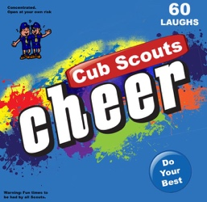
Cheers add fun to meetings and campfire programs. Use cheers during Cub Scout den meetings, pack meetings, or campfires. The cheer graphic can be printed and attached to a blue bag or a box wrapped in blue construction paper. Stuff the cheer box with themed cheers written on strips of paper before each meeting. Someone (e.g., assistant Cubmaster) should be assigned to jump up and enthusiastically lead cheers throughout the meeting (e.g., after a skit or advancement ceremony). Download the graphic at www.shac.org/Data/Sites/1/media/resources/leader-guides/Cheer-Box-1200x1170.jpg.

Applause stunts are a great way to recognize a person or den in a pack meeting for some accomplishment they have performed. Be sure before you start that everyone knows and understands the applause stunt and how to do it. Applause stunts serve more than one purpose -- they not only provide recognition but also help liven up a meeting. Applause stunts need to be fun. Strive for quality of performance in your stunts. Another important side effect of Applause stunts is they provide” wiggle time” for all the Scouts and siblings during the ceremonies so they sit still during the serious moments. It is a lot easier and a lot less stressful to lead a cheer and have fun than to be constantly reminding the Scouts to sit quietly.

Print: Cheers and Applause's (cut into strips and put in Cheer box)

Alligator Cheer
Everyone puts their arms out in front of their body palms together, open the jaws of the alligator by spreading the arms in vertical motion, slowly, then snapping the jaws shut very quickly. Do this three times!

Banana Cheer
“Peel bananas, peel peel bananas!” (Repeat twice. Pretend you’re peeling a banana.) “Go bananas, go go bananas!” (Repeat twice. Jump around, spin in a circle, punch fists in the air.)

Bear Hug Cheer
Put arms around your own shoulders and give yourself a big hug.

Bees in this Beehive Cheer
Instruct everyone to start humming.
Then as you raise your hands the humming gets louder.
When you lower your hands the humming gets quieter.

Bobcat Cheer
Stand up, give a loud “Meow!” three times.

Disco Mosquito Cheer
Slap 4 times—once on each cheek, once on each arm,
While singing “Oh, oh, oh, oh!”
Then point finger up and down
while singing, “Eaten alive! Eaten alive!”

Elephant Cheer
Let your arms act as trunk. Wave it in front of your face. Raise your arm up and roar.

Frog Pond Cheer
Divide into three groups.
Group 1, using high voices = “Tomatoes, tomatoes, tomatoes” Group 2, with medium voice = “Potatoes, potatoes, potatoes!”
Group 3, with deep bass voices = “Fried bacon, fried bacon, fried bacon!” Rehearse with each group; then add one group at a time.

Jungle Cheer
Assign cheers to roups.
Tiger Cubs: Roar like a tiger—RRRRR!
Wolf: Howl like a wolf—Ah-ooooo!
Bear: Growl like a bear—Grrrr!
Webelos: We’ll BE Loyal Scouts!
Cub Scouts: The sounds they used earlier
Moms: Screech like a hawk—Eyaw! Eyaw!
Dads: Yell like a monkey—Eeeek! Eeeek!
Other family members: Hiss like a snake—Hsss! Hsss!
Leader: Thank you to all the inhabitants of our jungle pack. Let’s give them a jungle cheer!

Giraffe Cheer
Stretch your neck up, stand on tip toes, “That was out of site!”

Monkey Cheer 1
Semi squat position. Raise hands to ribs under armpits.
Make motions of scratching and
Hop up and down saying, "Eeeek, Eeeek!"

Monkey Cheer 2
Ooo, Ooo, Ooo (while acting like a monkey)

Rainforest Cheer
Divide audience into 5 groups. Assign each group a part -
- Rubs palms together (wind)
- Snaps fingers slowly (first drops of rain)
- Claps hands, vary rhythms (steady, light rain)
- Slaps thighs (heavy rain)
- Stamps feet (downpour)
The Cubmaster points to the first group as they begin their action. Each group, once started, continues until the Cubmaster points at them a second time to stop. After the first group starts, the Cubmaster points to the second group, and then the third, and so on until all the groups are participating in a loud and crashing rain storm. Then the Cubmaster stops the groups in reverse order as the storm dissipates and calm returns.

Rainforest Cheer Variation
Have the Cub Scouts choose whether they want to make the sounds of rain, birds or insects in the jungle. You might even add larger animals. Make sure you have a good mix of sound – Cub Scouts can switch places so everyone can do various sounds. Each sound should stand in the same section. Have each section practice once. Now point to the various sections and have them produce their rainforest sounds. Have them get softer or louder by using hand signals. Try having everyone make their sound at the same time, or having one section louder than the others. Try making “daytime” sounds and “nighttime” sounds. What sounds would you hear if a predator was coming close? You could also check out a National Geographic or nature video that has those sounds and compare them to your own orchestra. Tape the sounds of your “orchestra” and use it for background music at the pack meeting.

Taming of the Wild Lion Cheer
Simulate having a chair and whip in hand.
Hold chair out and crack whip and yell "Back, back, back!"
Then Yell - "Help, Help, help, the lion has the whip.

Tarzan Cheer
“I like bananas (pantomime eating a banana), coconuts (throw a coconut), and grapes (eat grapes.) That’s why they call me (yell next part) Tarzan of the Apes!”

Tiger Cheer
That was G-R-R-R-R-R-R-R-E-A-T!

Tony the Tiger Cheer
Grrrrreat!

Watermelon Cheer
You take a big bite of a watermelon,
Chew it up good and now
You spit out the pits like a machine gun

Woodpecker Cheer
Knock on your chair 5 times.

Woody Woodpecker Cheer
http://www.youtube.com/watch?v=x22lCxYA-fs&feature=related

Zebra Cheer
“Zee-bra, zee-bra, ZEEEEEEE-BEST!”

PACK MEETING HANDOUT

Edit the text boxes on the next two pages. An editable, word version of this document is available at www.shac.org/jungle-theme
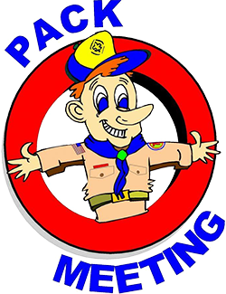
- Page 1: insert pack number and month/year
- Page 2: list detailed announcements, edit upcoming events for next three to six months, customize electronic communications.

Print one copy per person (of next two pages), one-sided to two-sided

Announcements: During meetings, keep announcement very short. Having detailed announcements printed in the handout saves times during meetings and avoids the dreaded long announcements that run on and on (that nobody can hear, nobody pays attention too and Scouts dislike). Encourage the parents to put the handout on their refrigerator. Parents will get used to getting a handout at each pack meeting.

In addition to upcoming pack events, Add district and council events. Visit www.shac.org/toolkit for upcoming council events. Visit your district website for upcoming district events.

Songs: have more songs than you think you need. You don’t have to sing them all, but having a back-up in case of a lull in the program is always helpful.

 | Pack <#> |  | 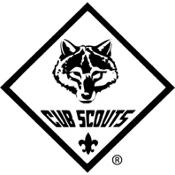 | <Month Year>
The Jungle Hokey Pokey  (Tune: Hokey-Pokey)  You put your Tiger foot in,  you put your Tiger foot out,  you put your Tiger foot in,  and you shake it all about.  You do the Hokey-Pokey  and you turn yourself around.  That’s what it’s all about.  (More verses: Monkey’s hand; Zebra tail; Giraffe’s neck; Toucan beak; Elephant’s trunk; Lion’s mane) |  | 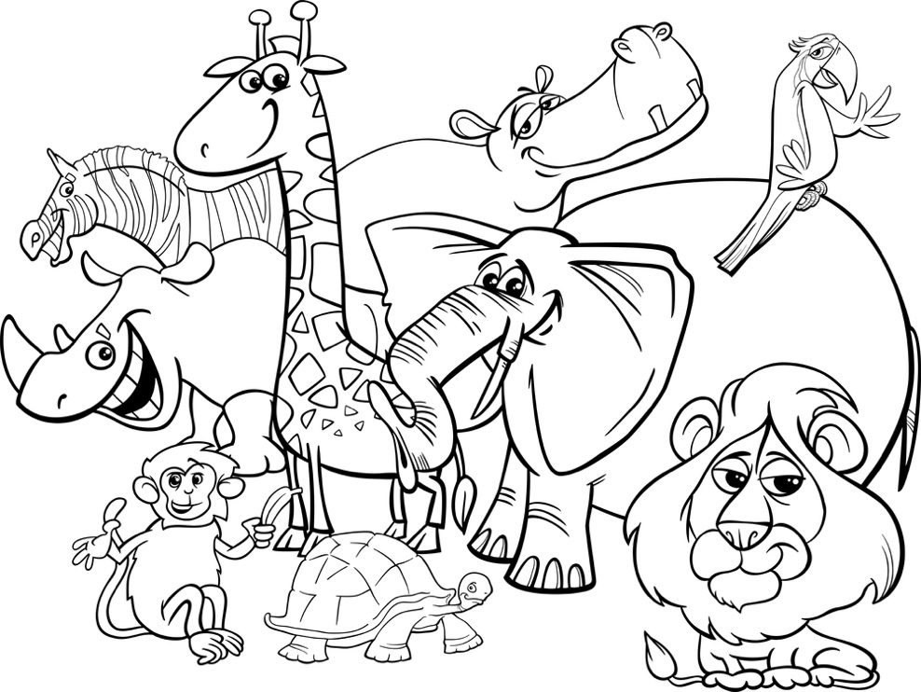 |  |  | 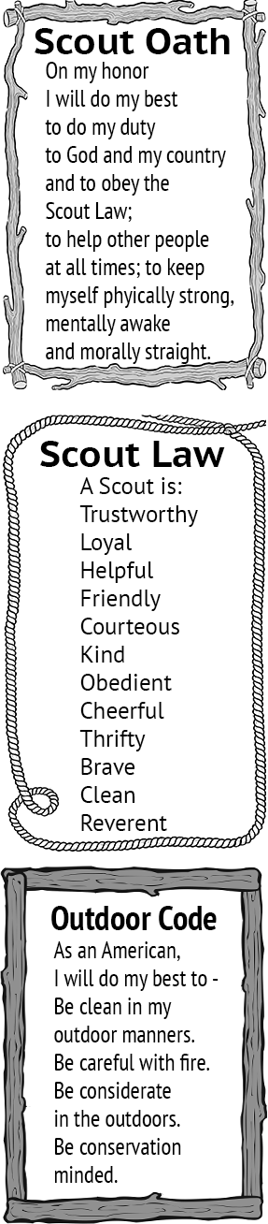
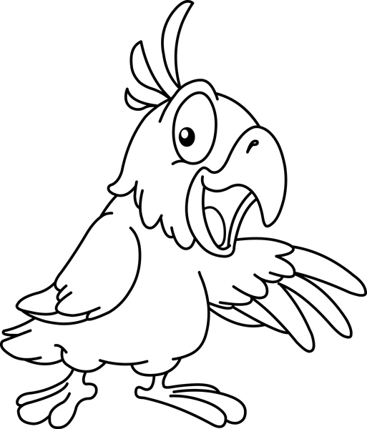 |  | Take Me Out to The Forest  (Tune: Take Me Out to The Ballgame)  Take me out to the forest.  Let me hike in the wild.  Show me a skunk and a few bear tracks.  I won't care if I never come back.  But it's look, look, look at your compass.  If it rains, then your wet.  And its ouch, slap, sting and you're bit in the great outdoors.
The Coming of the Frogs
(Tune: Battle Hymn of the Republic)
Mine eyes have seen the horror of the coming of the frogs,
They are sneaking thru the swamps and they are lurking in the logs.
You can hear their mournful croaking through the early morning fog.
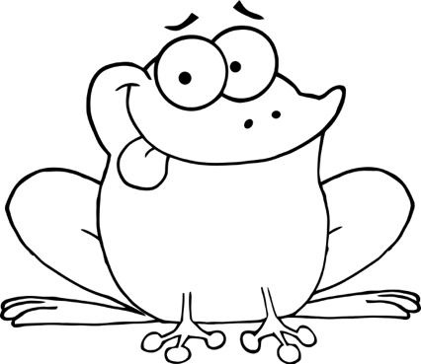
The frogs keep hopping on.

Chorus: (repeat after each verse)
Ribet, ribet, ribet, croak, croak.
Ribet, ribet, ribet, croak, croak.
Ribet, ribet, ribet, croak, croak.
The frogs keep hopping on.

The frogs have grown in numbers and their croaking fills the air.
There's no place to excape because the frogs are everywhere.
They've eaten all the flies and now they're hungry as a bear
The frogs keep hopping on. Chorus

They've hopped into the living room and headed down the hall,
They have trapped me in the corner and my back's against the wall.
And when I opened up my mouth to give the warning call, This was all I heard. Chorus

<insert announcements> |  |  |  | Upcoming Events  <Month Year>  <day> <event>  <day> <Den meeting>  <day> <Pack meeting>  <day> <District event>  <day> <Council event>  <Month Year>  <day> <event>  <day> <Den meeting>  <day> <Pack meeting>  <day> <District event>  <day> <Council event>  <Month Year>  <day> <event>  <day> <Den meeting>  <day> <Pack meeting>  <day> <District event>  <day> <Council event>
<insert pack committee and contact information> |  | Pack <#>  facebook.com/<insert URL>  <pack website>  <insert> District  <district website>  facebook.com/<insert URL>  Sam Houston Area Council  www.shac.org  facebook.com/shac.bsa

BANQUET PROGRAM

A formal handout for banquets.

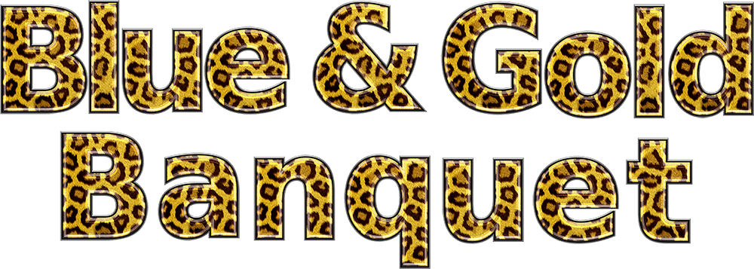
Edit the text boxes in the next two pages (insert Scout’s names, upcoming events, pack number, agenda and date). An editable, word version of this document is available at www.shac.org/jungle-theme.

Banquets: Most packs celebrate Scouting Anniversary Week in February with a birthday party called the blue and gold banquet; some packs do end of the year banquets. It brings families together for fun and cheer. The purpose of a banquet is to celebrate the Scouting, thank leaders and volunteers, and inspire the leaders, Scouts, and parents.

The banquet can be like a regular pack meeting with songs, skits, stunts, and awards, or it can be something different and a little more special. The pack committee may decide to bring in an entertainer such as a mad scientist or magician and have a video or slide show of what the pack did over the past year.

A good banquet needs lots of careful planning at least two months in advance to be successful. The pack committee should recruit a banquet chair, who in turn may select others to carry out the responsibilities of the program, such as making physical arrangements, promotions, inviting special guests, decorations, choosing a theme, ordering food, etc. Try to involve as many people as possible, but avoid giving den leaders too many additional responsibilities because it may distract them from their duties to their dens.

A detailed plan for banquets, including a planning calendar, sample agenda, and suggested program activities, is available in the Cub Scout Leader How-To Book, No. 621165.

Banquet Planning: www.skcscouts.org/wp-content/uploads/2013/06/Blue-Gold-Planning-Guide.pdf

Banquet Planning: www.ocbsa.org/wp-content/uploads/2011/06/Blue-Golf-Banquet-for-Website.pdf

Upcoming Events
Pack 123
Blue and Gold
Banquet

February 1, 2019

February 11, 2017 University of Scouting (leader training; www.shac.org/uos)

March xx, 2017 Pack Meeting

April xx, 2017 Pack Meeting

May 5, 2017 Scout Fair (shac.org/scout-fair)
May xx, 2017 Pack Meeting

June xx-xx, 2017 Day Camp (www.shac.org/day-camp)

July xx, 2017 Pack summer time activity #2
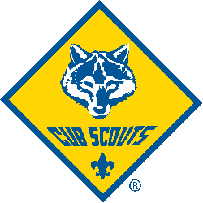
July 2017 Resident Camp (www.shac.org/resident-camp)

August xx, 2017 Pack summer time activity #3

Communication Tools

Pack website
Pack Facebook page

District website
District Facebook page

www.shac.org
www.facebook.com/shac.bsa
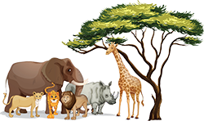
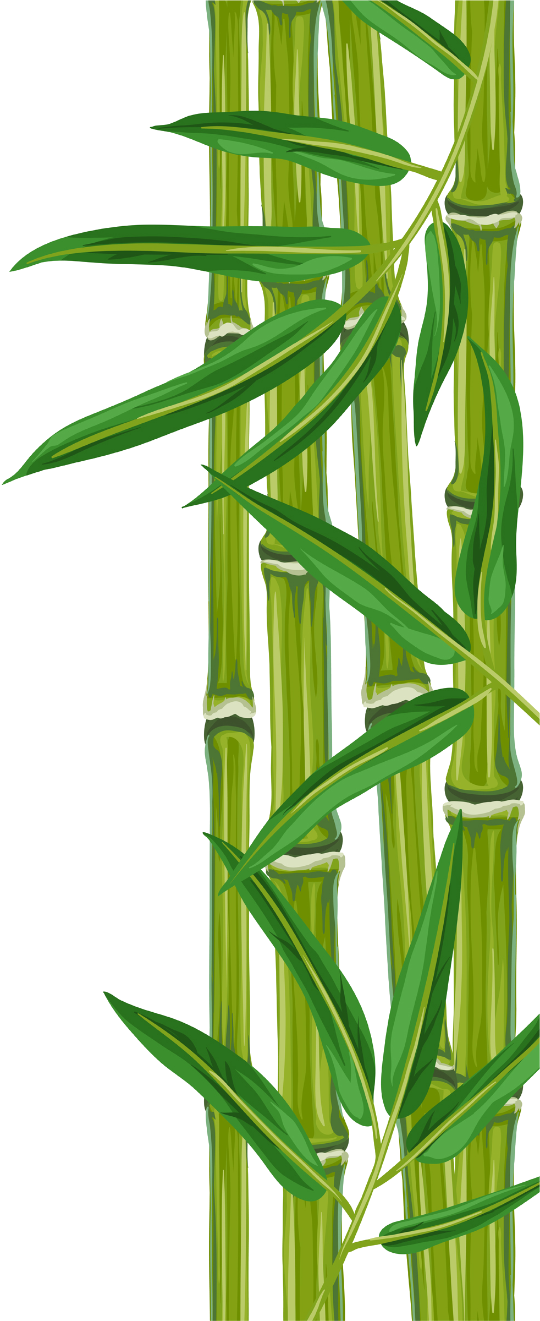
Gathering
The Jungle Hokey Pokey
(Tune: Hokey-Pokey)
You put your Tiger foot in, you put your
Tiger foot out, you put your Tiger foot in,
and you shake it all about.
You do the Hokey-Pokey and you
turn yourself around.
That’s what it’s all about.
(More verses: Monkey’s hand;
Zebra tail; Giraffe’s neck; Toucan beak;
Elephant’s trunk; Lion’s mane)

Take Me Out to The Forest
(Tune: Take Me Out to The Ballgame)
Take me out to the forest. Let me hike in the wild.
Show me a skunk and a few bear tracks.
I won't care if I never come back.
But it's look, look, at your compass.
If it rains, then your wet.
And its ouch, slap, sting
and you're bit in the great outdoors.

The Coming of the Frogs
(Tune: Battle Hymn of the Republic)
Mine eyes have seen the horror of the coming of the frogs,
They are sneaking thru the swamps and they are lurking in the logs.
You can hear their mournful croaking through the early morning fog.
The frogs keep hopping on.

Chorus: (repeat after each verse)
Ribet, ribet, ribet, croak, croak.
Ribet, ribet, ribet, croak, croak.
Ribet, ribet, ribet, croak, croak.
The frogs keep hopping on.

The frogs have grown in numbers and their croaking fills the air.
There's no place to excape because the frogs are everywhere.
They've eaten all the flies and now they're hungry as a bear
The frogs keep hopping on. Chorus

They've hopped into the living room and headed down the hall,
They have trapped me in the corner and my back's against the wall.
And when I opened up my mouth to give the warning call,
This was all I heard. Chorus

Welcome Name
Cubmaster

Opening Webelos
Den 6

Flag Ceremony Webelos
Den 4

Invocation Name
Title
Dinner

FOS Presentation Name
Title

Advancement Ceremony Name
Cubmaster

Song Wolves
Den 1

Leader Recognition Name
Committee Chair

Skit Tigers
Den 3

Cubmaster Minute Name
Cubmaster

Closing Bears
Den 5

GATHERING ACTIVITIES

Animal Collectives
See how well you know your animals. What is the correct terms for groups of the following animals?
- A gaggle of (geese)
- A of hawks (hawk)
- A of cattle (herd)
- A of quail (covey)
- A of sheep (flock)
- A of elk (gang)
- A pod of (whales)
- A of wolves (pack)
- A of porpoises (shoal)
- A of oxen (drove)
- A of hens. (flock)
- A school of (fish)
- A pride of (lion)
- A of buffaloes (herd)

Animal Scrambles
Two by Two
- Prepare two identical lists of names of animals and
- Cut them into strips.
- Give each Cub Scout one of these slips of paper.
- After someone has their animal, they must make the sound of that animal until they find the matching animal.
- Be sure to pick animals that the Cub Scouts can make their noise.
A fun prank for a leader who is a good sport, is to give him or her an animal that has no match. Then at the end of the game they are the only one making an animal sound.
As a Group When everyone comes into pack meeting, give each person one name of a variety of five different kinds of animals. Instruct them to keep it a secret. Then have everyone scatter and start making the noise of their animal, in the attempt of attracting the others of their kind.
When you find others of your species, take their hands. Continue to make the noise until everyone is gathered together.

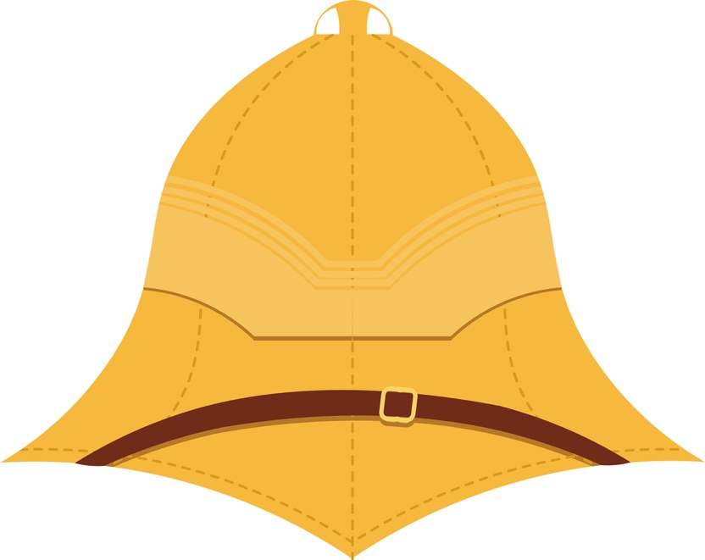

Baby Animal Match Up Game
Can you find the matches? Draw a line from the baby animal's name to its mother's name.
MOM BABY
Tiger Kid
Elephant Cow Pullet
Ewe Piglet
Nanny Gosling
Sow Foal
Hen Calf
Goose Leveret
Owl Chick
Mare Lamb
Turkey Hen Owlet
Hare Cub
Answers: Tiger/Cub, Elephant cow/Calf, Ewe/Lamb, Nanny/Kid, Sow/Piglet, Hen/Chick, Goose/Gosling, Owl/Owlet, Mare/Foal, Turkey Hen/Pullet, Hare/Leveret

Baden-Powell or Kipling?
Have a team competition based on Baden-Powell and Kipling – use the ideas below, or make up your own questions using the information in “Fun Connections” under Theme Related.
Look at the following facts. Some of them refer to Baden-Powell, some to his friend Rudyard Kipling, who wrote the Jungle Book, and some to both men.

His father was a clergyman and also wrote books.

He lived in both India and America.

He wrote many books, and also illustrated them.

He was able to draw with either his right or left hand, and sometimes with both!

He wrote the first official scout song.

He created “Kim’s Game,” which is still played by scouts around the world.

He spent time in South Africa when it was part of the British Empire.

He loved to go “motoring” and owned a Rolls-Royce.

He was a “Commissioner for Scouts” and wrote a book especially for Wolf cubs.

He was buried in Africa at his request, but has a memorial plaque in Westminster Abbey near where his friend is buried.

Answers: #1, 3, 7, 8 refer to both men. #2, #5, #6, and #9 refer to Kipling only. #4 and #10 refer only to Baden-Powell.

Learn lots of interesting things about
both Baden-Powell and Kipling at: www.scouting.milestones.btinternet.co.uk/kipling.htm

How Many Can You List
Give out blank sheets of paper and ask each person to list as many jungle animals as they can. Who can come up with the biggest list?

How Observant Are You?
Before your meeting starts, prepare about a dozen objects (e.g. a homemade spider hanging on a thread in an easy-to-see place; a rubber snake fastened to the back of the Cubmaster’s belt; a den leader with a fake honey bee in her hair; a butterfly on a father’s shoulder). Just before the meeting starts, ask, by a show of hands, how many have spotted the spider, snake, etc. You now have their attention; proceed with your meeting.

Hunter and Lion
Blindfold two players. a "hunter" and a "lion". Seat them at the opposite ends of a table. Placing hands on top of the table. On signal the hunter moves at will around the table while the lion evades him. Explain that neither may leave the table, when the lion is tagged have them become the hunter and appoint a new lion.

Jungle Mix-Up
Happens in the best of worlds so what do you expect in the jungle? A bunch of the beasts have gotten mixed up and only the Cub Scouts can get things back together again. Make up signs using jungle animal names, but cut each name “in half.” As people get to the meeting room, give each one a “half name” and the instructions to find their other (better?) half. When the pair finally get together, they need to practice the animal sound associated with their species. Later, during the meeting, set side a jungle noise time to see just how jungle-like the group can make the place sound.

Jungle Mural
Set up a large jungle mural with no animals. Have family members make animals to add to the jungle mural.
Even the youngest kids could make bugs or butterflies out of small paper plates or coffee filters and pipe cleaners. Others could make a bird out of colored paper or fun foam and feathers. Provide glue, markers and googly eyes.

Jungle Puppets
Have a variety of “walking finger puppets based on jungle animals available. Each Cub Scout or person can choose one to color and play with.

Jungle Photos
Set up “photo op” jungle sites and take pictures of Cub Scouts and family members either dressed as explorers, or sticking their heads thru a painted scene showing jungle animals and/or explorers.

Jungle Who Am I?
Have a variety of pictures of different jungle animals.
Tape one to each person's back,
Then they must locate others of their “species” by asking only “yes or no” questions.

Nature Did it First
For most modern inventions there already exists a counterpart in nature. Here is a list of animals and the inventions. Try matching the animal with the invention.
1. Bat A. Parachute
2. Armadillo B. Snowshoes
3. Chameleon C. Helicopter
4. Eel D. Suction Cup
5. Flying Squirrel E. Hypodermic
6. Squid F. Radar
7. Hummingbird G. Camouflage
8. Snake H. Electricity
9. Abalone I. Tank
10. Caribou J. Jet Propulsion

Answers - 1F, 2I, 3G, 4H, 5A, 6D, 7C, 8E, 9J, 10B

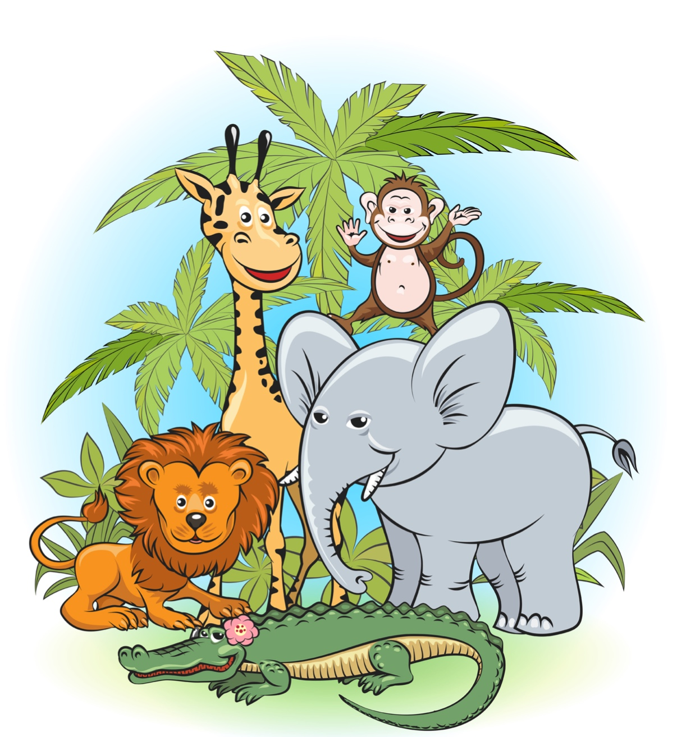

Opening Quiz
On Safari you will see lots of wild animals, some of them on the endangered list. We need to make sure that we humans let the rest of the animal kingdom also live and enjoy life.
Can you figure out what animals we are describing?
# | Animal  Name | Clue
1 |  | I'm, yellow and I'm a cat.  I'm lean and never fat.  I hunt and eat meat.  I'm big, striped and fleet.
2 |  | I'm very large and wide,  I have a loose, gray hide.  I have a nose that is like a hand,  I like to stand in water and sand.
3 |  | Some call me a slinking coward,  I don't mind eating what's soured.  I have a giggle that's kind of unpleasant.  My front legs are long, in back I'm a runt.
4 |  | I'm quite soft and definitely slinky,  My coat's color is black and inky.  If you don't notice when I'm high in a tree  It's because I'm a cat and climb expertly.
5 |  | Some call me the "King of Beasts"  I like to have meat for my feasts  On the plains I reside  With my family called a "pride".
6 |  | My coat is spotted and tan,  I eat all the tree leaves I can.  My neck is extremely strong,  Because it is very long.
7 |  | Some think I'm really cute,  I eat grass, but not the root.  I'd rather run then fight,  My hide's striped black and white.
8 |  | I lie in the mud and wait,  If you come close I'll demonstrate  How many teeth line my extended snout,  I'm a reptile with legs and with clout.
9 |  | I'm built kind of like a tank,  I live on the river banks  My legs look like stumps,  I eat water plants in clumps.
10 |  | I'm big and my eyesight's not great,  If I change I can exterminate  I have a sharp horn on my nose,  My hide is tough, I stand up to doze.
Answers: 1. Tiger, 2. Elephant, 3. Hyena, 4. Panther, 5. Lion,
6. Giraffe, 7. Zebra, 8. Alligator or Crocodile,
9. Hippopotamus, 10. Rhinoceros

Safari Portrait
Each player has a pencil and a sheet of paper, fold the paper into three sections, and each artist draws the head of the animal they think of on the safari and passes the paper on to the next artist, each then draws the body and then passes the paper one more time to create the feet of the animal. Each time the players hand the sheet of paper to the next person they show only the blank section, and have it ready for the next artist, Now everyone opens the portraits to see the unique animals on the safari.

Safari Memory Game
Make up pairs of cards with safari animals:
Zebra Lion Elephant
Gazelle Jackal Vulture
Hyena Cheetah Monkey
Wildebeest Tiger Rhinoceros
Crocodile Leopard Hippopotamus
Giraffe Gnu Ape
Shuffle them well, and lay them out neatly face down. The first player chooses two cards, turns them over so everyone can see them, and if they match the player takes the matching cards and tries again. If they don't match they are turned back over and the next player turns two cards over trying to find a match. Every time a player finds a match they get another turn.
Winner is the player with the most pairs.

Safari Tactile Test
The materials for this one may be tough to come by, but I think if you look around enough, you’ll find them. Get miniatures of as many safari animals as you can (like those plastic “farm animal” sets, only safari animals). Put each one into its own “blind box” with holes cut in to feel the animal. Set these around the meeting room for people to try to feel out what the different animals are.

Spell That Animal
Place letter cards out on the tables in front of the individual groups. Call out a name of an animal and have them try to spell it out in the correct order within a minute time frame.
Make up pairs of cards with safari animals:

What Am I
This is a jungle animal matching game. Download or otherwise come up with some pictures of different safari animals and mount them to hang around the meeting room—make sure to mark them for identification (e.g., 1, 2, 3, etc.). Give people sheets of paper to try listing all of the animals they see. Check on how many people were able to identify how many animals. I bet the kids did better than the adults!

Where do I live?
Use the mural the Cub Scouts have made for your background. Give each person an animal cutout and tell them to place the animal on the right level of the jungle. This could either be an individual, den, team or family contest. When all the animals have been placed, go through and tell everyone where each animal really lives – you might make a card for each animal describing the name, where it lives, how it protects itself, what it eats – each Cub Scout can take a turn reading about an animal.
Your could also print out a picture of the rainforest or jungle canopy and give each family or team animal and/or plant stickers or printouts to place on their page. The team with the most right answers gets to have refreshments first.

Walking Through the Jungle
Directions – This is a "Follow the Leader" activity. Pretend to walk very carefully through the jungle and mime the actions to suggest each animal. It's easy to make up more verses for this rhyme. As Scouts arrive, invite them to join in the walk, and see if they can create the verses.
Walking through the jungle,
What did I see?
A big lion roaring
At me, me, me!
Walking through the jungle,
What did I see?
A baby monkey laughing
At me, me, me!
Walking through the jungle,
What did I see?
A slippery snake hissing
At me, me, me!
Walking through the jungle,
What did I see?
A beautiful toucan flying
Over me, me, me!
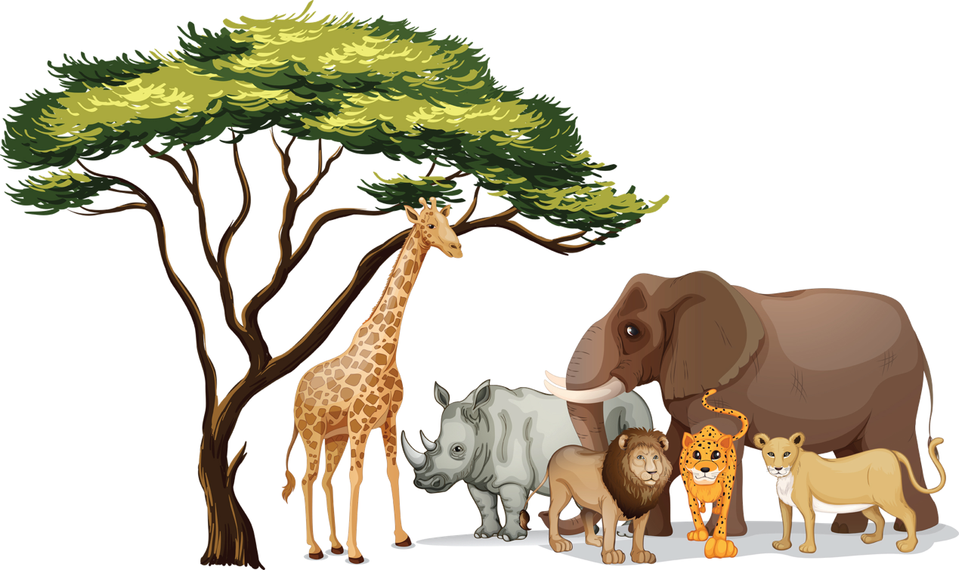

OPENING CEREMONIES

Adventure Opening
Setting – Cubmaster (CM) and 9 Cub Scouts holding the letters to A-D-V-E-N-T-U-R-E with the appropriate verses on the back.
Scene – Scouts stand in a line to spell ADVENTURE.
#1: A Action packed!
#2: D Definitely fun!
#3: V Visions of awards!
#4: E Expect a great program!
#5: N New friends!
#6: T Trying our best!
#7: U Using our skills!
#8: R Ready for a song!
#9: E Enabling us to perform!
CM: Our Scouts have just shared with us their expectations of tonight’s adventure with our theme, Jungle Safari. We’re glad you’re here to journey with us. As we begin, please stand and join us in the Pledge of Allegiance.

Cub Scout Safari Opening
5 Scouts and Cubmaster driving a cardboard jeep with safari hats on Committee Chairperson: We're so glad you could join us on our safari tonight. Our fearless leader (Cubmaster's name) will be driving our jeep. But as with any trip there are a few instructions you must hear.
(2 Cub Scouts jump out of the jeep and start chasing each other)
1st passenger still in jeep: Johnny Lion, what are you doing?
One Of The Cub Scouts Running: I'm chasing a hunter around a tree.
2nd Passenger Still In JeEP: How many times have I told you not to play with your food. (All go back to jeep)
Next Cub Scout gets out of jeep and says:
Bobby had a kitten
Tommy had a pup.
Johnny had a crocodile
That ate the others up.
(Cubmaster climbs out of jeep and looks at Committee Chairperson) What has fifty legs, big blue eyes on stems, and a red body with green stripes?
Committee Chairperson: I don't know. What?
CM: I don't know either, but it's crawling up your shirt right now. So everyone climb aboard the jeep and watch out for wild animals! "Cause we're taking you on a Cub Scout Safari.

Cub Scout Safari Opening
(For best effect you should use the Cub Scout Safari Closing that goes with this Opening)
Equipment:
- Two galleries - These can be placed on a chalk board, wall, boxes, or whatever else will work with the room arrangement that you have. The galleries will be on display throughout the meeting.
- Framed pictures of the animals mentioned in the opening and closing ceremonies. The den leader could have the Cub Scouts draw the pictures from books during den meeting and put the pictures in simple paper frames. Two frames that have the word "NEXT" in them, pins or tape to hang the pictures in the gallery.
Personnel: Narrator, Cub Scouts
Set up: Cubs stand in a line holding their pictures, so that they cannot be seen until the proper time in the ceremonies. After the Cub Scouts show their picture, they hang the pictures in the gallery. In the opening, this should be done solemnly.
Narrator: Tonight we are going on a Cub Scout Safari. But ours will not be just in Africa. We will see animals from around the world. Beautiful animals. In fact, maybe they were too beautiful or lived somewhere too valuable. The first part of our Safari is sad because these animals we can no longer see except in pictures. They are gone forever. They are extinct.
(The Cub Scouts now show their pictures while saying the name of the animal they are showing. Have pictures of enough extinct animals so each Cub Scout in the den has one)

Jungle Safari Theme Opening

Material: Preprinted cards with large letter on one side and script on opposite side. Personnel: 13 people
Each person holds up sign as they say their part. Audience responds to each one.

#1: “J” is for Jaguar.
#2: “U” is for Umbrella Tree.
#3: “N” is for Nocturnal Sloth.
#4: “G” is for Gorilla.
#5: “L” is for Lion.
#6: “E” is for Elephant.
#7: “S” is for Scouts.
#8: “A” is for Adult Leaders..”
#9: “F” is for Family..”
#10: “A” is for Adventure.
#11: “R” is for Roundup.
#12: “I” is for Inspiration.
#13: What does that spell?
All: Jungle Safari!!!
#13: Welcome to our Jungle Adventure Blue and Gold Banquet (or Cub Scout Day Camp). Please join us in the Pledge of Allegiance.

Safari Opening
At the signal of the denner, all Cub Scouts hide nearby. Den Chief then stands in center of room and calls, “Bobcats”.
All Bobcats come from hiding, crying “Me-o-ow~ Me-o-ow~”or whatever your den has decided is the cry of a Bobcat. These Cub Scouts continue crying while Den
Chief calls for “Wolves”. They come howling, Then the “Bears” come growling, ferociously. Now the entire den is in full cry.
The Den Chief makes the Cub Scout sign (followed by the Cub Scouts), then calls: “Akela welcomes the jungle animals to their den. Let’s see to it that we work and play in peace and become strong and wise Cub Scouts.” Now the den chief has everyone stand and repeat the Pledge of Allegiance.

Safari Flag Opening Ceremony
Setting – 6 Cub Scouts each with one letter from S-A-F-A-R-I and an appropriate picture if you wish on front and the appropriate words on back in LARGE print..
#1: S - Sing for your country. An
#2: A - Anthem on high...for unparalleled
#3: F - Freedoms which our
#4: A - Ancestors could not even imagine. Let's
#5: R - Revere our God for letting us be able to live unprecedented
#6: I - Independence and plenty...which we enjoy...Let us now say the pledge.

Spirit of the Jungle Opening Ceremony
Setting – Eight Cub Scouts each with a sign that has an appropriate picture on front and the words on back in LARGE print..
#1: We have been learning about the jungle’s treasures.
#2: We will help to maintain the jungle’s balance.
#3: We will help and learn from the jungle animals.
#4: We will help maintain the jungle’s resources.
#5: We will protect them from harm.
#: We will follow the laws of the jungle.
#7: We will abide by the Outdoor Code:
As an American, I will do my best to
Be clean in my outdoor manners.
Be careful with fire.
Be considerate in the outdoors.
Be conservation minded.
#8: Please stand and join us in the Pledge of Allegiance.

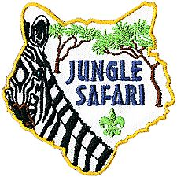

“What Do I See” Opening
Equipment: Six cards with a picture depicting each line.
Personnel: Camp Director and six Cubs or people.
# 1: What do I see when I see a Tree? Oranges and apples and peaches to eat.
# 2: What do I see when I see a Tree? A Pinewood Derby car made by dad or mom and me.
# 3: What do I see when I see a Tree? Paper for books an magazines for me.
# 4: What do I see when I see a Tree? The walls of the house of my family.
# 5: What do I see when I see a Tree? The hulls of early ships sailing the sea.
# 6: What do I see when I see a Tree? The staff of the flag that stands before me.
CM: In honor of our flag that flies so free, would you stand and join me in the Pledge of Allegiance.

What Kind of Cub
Personnel - Den Leader (DL) and 5 (or more) Cub Scouts
DL: (Wearing a safari hat) I'm looking for a Cub.
#1: What kind of Cub?
DL: (Still looking about) Oh, I don't know, but I'll know it when I see it.
#1: Is it a Tiger Cub?
(A second Cub Scout crawls along the floor and roars)
DL: No! It's not a Lion cub
#1: Is it a Bear cub?
(A third Cub Scout crawls along the floor and growls)
DL: No! it's not a Bear cub
#1: Is it a Wolf cub
(A fourth Cub Scout crawls along the floor and howls)
DL: No! It's not a Wolf cub
#1: Well what other type of cub is there?
DL: There it is!
(A fifth Cub Scout in full uniform walks in, carrying the American Flag)
#5: (Turns to the audience and says) Repeat with me the pledge of Allegiance

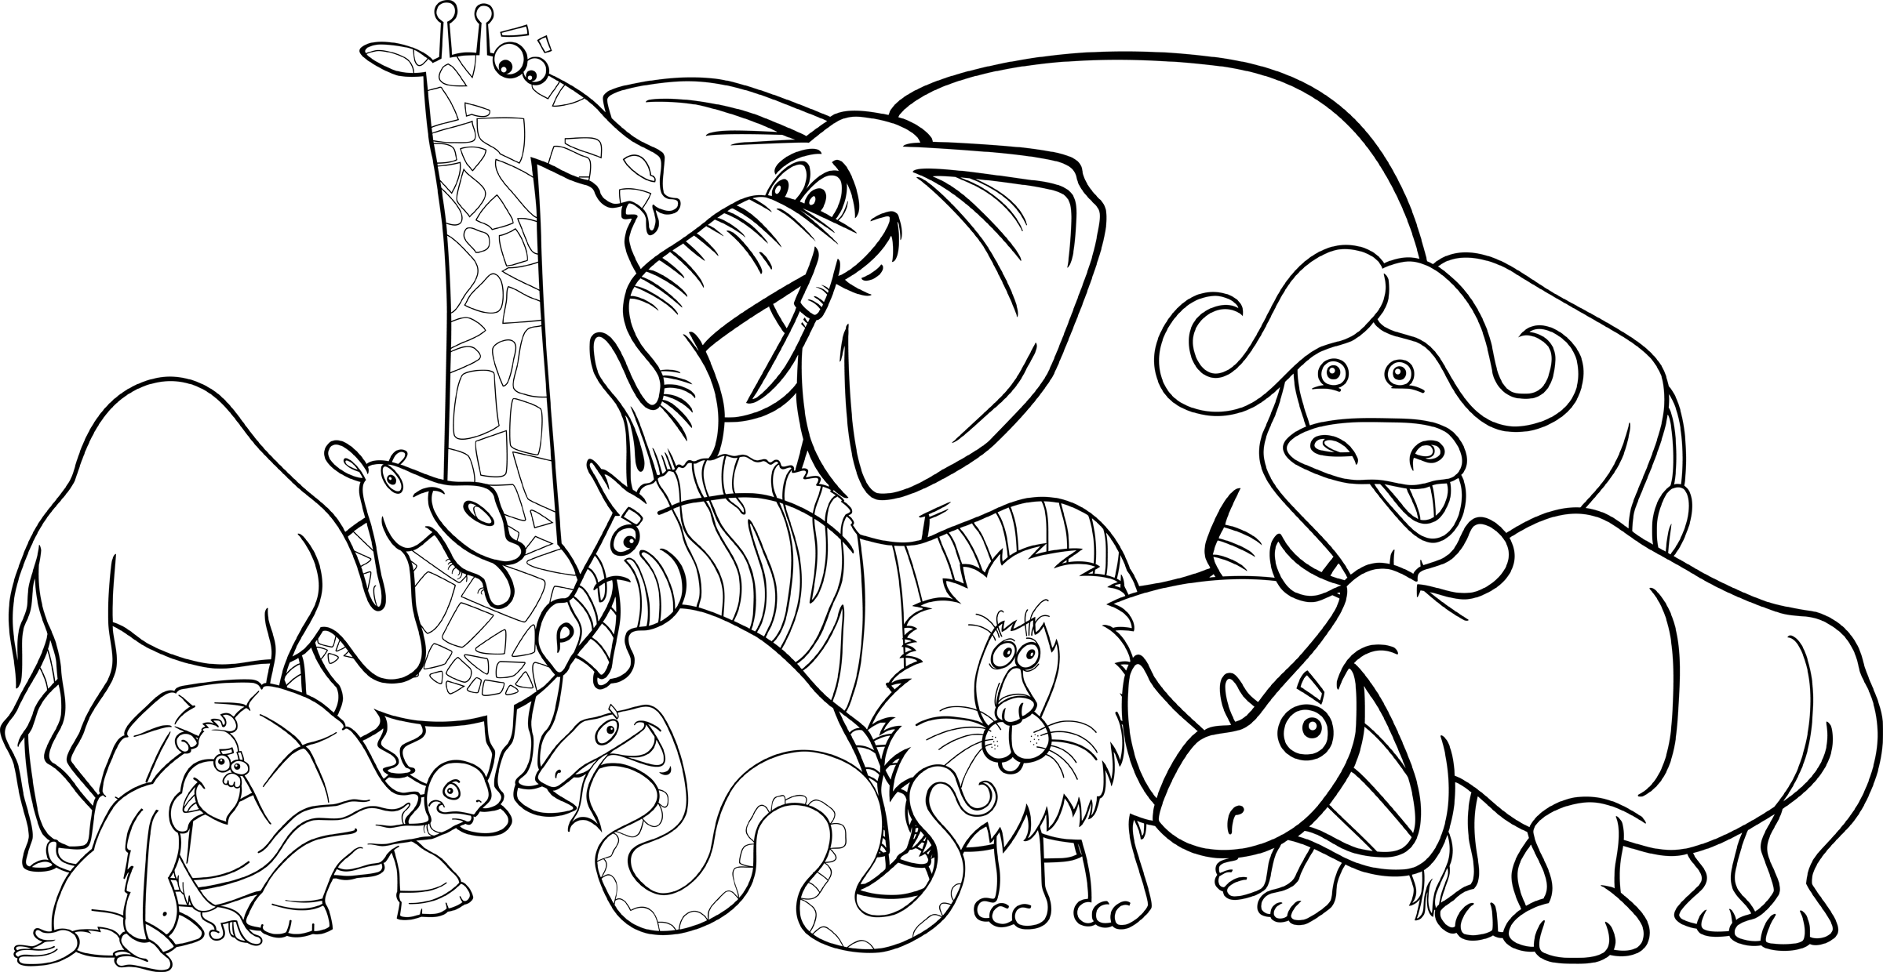
INVOCATION

Jungle Book Invocation

We approach Thee, and ask Thee to join Thy love for the Cub Scouts. Join with us as we begin our blue and gold banquet (or day camp). Grant us the patience as we teach our Cub Scouts.

Grant us the strength as we protect the Cub Scout that have been entrusted to our care. Grant us wisdom. Help us to do our best, to do our duty to God and to our country. Provide us the opportunities to help other people. Help us to obey the Scout Law and Scout Oath. In all of this we can teach the Cub Scouts in our care by our example, which will speak louder than our words. AMEN

Prayer for the Wild Things

Oh, Great Spirit, we come to you with love and gratitude for all living things. We now pray especially for our relatives of the wilderness – the four-legged, the winged, those that live in the waters, and those that crawl upon the land. Bless them that they might continue to live in freedom and enjoy their right to be wild. Fill our hearts with tolerance, appreciation, and respect for all living things so that we might live together in harmony and in peace.

AUDIENCE PARTICIPATION

Mowgli Learns the Law of the Pack
Divide the audience into 6 groups. Assign each group one of the words listed below. When their item is mentioned in the story, the assigned group should shout the designated saying. Have a practice session before starting the story.
(Or 5 groups and have everybody make noise on Jungle)
MOWGLI: I’m ready to learn!
AKELA: Leader of the Pack
BALOO: GROWL
WOLF (and WOLVES): HOWL
PACK: Do Your Best
JUNGLE: screeching sounds like monkeys
Long ago in the JUNGLES of India a small boy was separated from his family when his village was raided by the fierce tiger, Shere Khan. Amazingly, the boy was found and cared for by a family of WOLVES who lived in the JUNGLES. The WOLVES named the boy MOWGLI and welcomed him as one of their own WOLF cubs.
The wise leader of the WOLF PACK was named AKELA. The WOLF family asked him if MOWGLI could join their PACK. At the next PACK council AKELA asked, “Who speaks for this cub?”
At first there was no answer, but finally BALOO, the wise, old brown bear who taught the WOLF cubs the Law of the PACK, stood up on his hind paws and said, “I speak for the man-cub. I, BALOO, will teach him the Law of the PACK.” So, AKELA accepted MOWGLI, the man-cub into the PACK. And this is how MOWGLI came to live with the WOLF family in the JUNGLES and learn the ways of a WOLF cub.
As MOWGLI grew older, he learned the ways of the JUNGLES, too. BALOO taught MOWGLI and the WOLF cubs about the dangers of the JUNGLES and the secret language of the JUNGLES animals. They learned which animals were friends, like Bagheera, the black panther, and which were not, like Shere Khan, the tiger.
BALOO told MOWGLI to always listen to and follow AKELA, the WOLF leader. BALOO also taught MOWGLI to always think of the other WOLF cubs in the PACK and to take care of each other. The wise bear showed MOWGLI that the WOLF cubs in the PACK can learn things from each other when they work and play together. The WOLF cubs and MOWGLI learned to help others in the JUNGLES, too.
Though BALOO did his best to teach MOWGLI how to stay safe in the JUNGLES, there were times when the man-cub got into trouble. MOWGLI discovered that he needed AKELA, BALOO, and his older friends in the JUNGLES to teach him things that would protect him. If he followed the Law of the PACK, one day MOWGLI would become wise like his leaders in the JUNGLES.

The Mighty Hunter
Divide the audience into 5 groups. Assign each group one of the words listed below. When their item is mentioned in the story, the assigned group should shout the designated saying. Practice as you make assignments or have a practice session before starting the story.
LION – Loud roar
TARZAN – A-a-a-a-a-a-a-a-ahhhh! (Tarzan yell)
CHEETAH – Chee, chee, chee (with monkey movements)
MIGHTY HUNTER –Ready, aim (get ready to shoot)
JEEP –Beep, beep!
Note - there are only 4 occurrences of the word JEEP. You may want to skip that word.
Last August, a MIGHTY HUNTER decided to go on a LION hunt in the deep, dark jungles of India. The MIGHTY HUNTER boarded the plane en route to India, day dreaming about this exciting LION hunt. A long flight brought the MIGHTY HUNTER to the deep, dark jungles of India. And who should meet the plane but the famous TARZAN and his chimp friend, CHEETAH. The MIGHTY HUNTER was delighted to meet the much talked about TARZAN. CHEETAH proved so much fun to play with that the MIGHTY HUNTER almost forgot about the LION hunt.The next morning, TARZAN woke the MIGHTY HUNTER, telling him that CHEETAH had prepared a breakfast feast. They ate plates and plates of anaconda eggs, wild boar bacon, gazelle milk and fresh jungle fruit, picked right from the trees around them. CHEETAH was a very good cook. After the fantastic breakfast, the MIGHTY HUNTER prepared himself for the LION hunt. He made sure all the provisions were in the JEEP, and checked his gun to make sure he had enough ammunition. With his jungle hat on his head, and his gun in hand, the MIGHTY HUNTER, along with TARZAN and CHEETAH, set out on the JEEP for the much anticipated LION hunt.It was almost noon when CHEETAH started making strange noises and started jumping up and down wildly. TARZAN told the MIGHTY HUNTER that CHEETAH could smell a LION. The MIGHTY HUNTER took a deep breath and could feel his heart beat faster and faster. TARZAN jumped out of the JEEP, with CHEETAH close behind. The MIGHTY HUNTER followed closely, and, watching carefully, he saw TARZAN point to a group of trees about 60 feet away. Almost hypnotized, the MIGHTY HUNTER, TARZAN and CHEETAH watched as a tiny LION cub stepped out from behind the trees and inched his way closer to the group. TARZAN carefully walked to the tiny cub and picked him up. TARZAN looked everywhere for the LION’s mother, but she was nowhere to be found. Perhaps she had heard the JEEP coming and hid the cub, then ran away. The MIGHTY HUNTER realized they had saved the life of the LION cub. TARZAN was not surprised when the MIGHTY HUNTER announced that his hunting trip was over. Instead of the MIGHTY HUNTER taking home a LION head trophy, he took home a real live LION cub for the zoo. That way, many people could enjoy watching the LION cub grow up. But what a surprise awaited the MIGHTY HUNTER. As he walked up the boarding ramp to this plane, CHEETAH ran after him, jumped into his arms, and planted a big kiss right on the cheek of the MIGHTY HUNTER.
The Story of a Pack – Like Ours?
Divide the audience into 5 groups (or use the Dens and Parents). Assign each group one of the words listed below. When their item is mentioned in the story, the assigned group should shout the designated saying. Practice as you make assignments or have a practice session before starting the story.
TIGER - "They're Great!"
WOLF - (your best wolf howl)
BEAR - "Grrrr, grrrrr!"
WEBELOS - "To the top!"
PARENTS - "I'll help, I'll help!"
Everyone joins in on this next one -
PACK - "We're #1
Once upon a time there was a pretty good PACK who did a lot of things and had a lot of fun. The PACK had a few new TIGERS who had just joined the PACK with a lot of other Cub Scouts waiting to join. There were also a few WOLF Cub Scouts, who were eight years old. Most of the Cub Scouts in the PACK were BEARS, who were 9 years old and some of these BEARS were almost 10 years old. After a Cub has been a TIGER, WOLF, and BEAR, he becomes a WEBELOS.
WEBELOS means We'll be loyal Scouts. The WEBELOS program differs from the TIGER, WOLF, and BEAR because it prepares the WEBELOS Scout to be a Scout in a troop. The WEBELOS uniform is different, too. The TIGERS learn to Search, Discover & Share with their PARENT partners. WOLF and BEAR Scouts work on achievements and electives for gold and silver arrows with their PARENTS. The WEBELOS work toward activity pins.
All these awards are presented at the PACK meeting for all the PARENTS to see. The PACK was going along real well until summer came and a few PARENTS moved. The PACK now greatly needs PARENTS of the TIGERS, WOLVES, BEARS, and WEBELOS to help the PACK. The PACK needs the PARENTS’ help so the PACK can grow and continue to provide lots of fun for the TIGER, WOLF, BEAR and WEBELOS Scouts!
The PACK can't do its best job with only a few PARENTS doing everything, so PARENTS, help your TIGER, WOLF, BEAR and WEBELOS Scouts get a better program of fun and adventure in our PACK by volunteering now. What do you say, PARENTS?
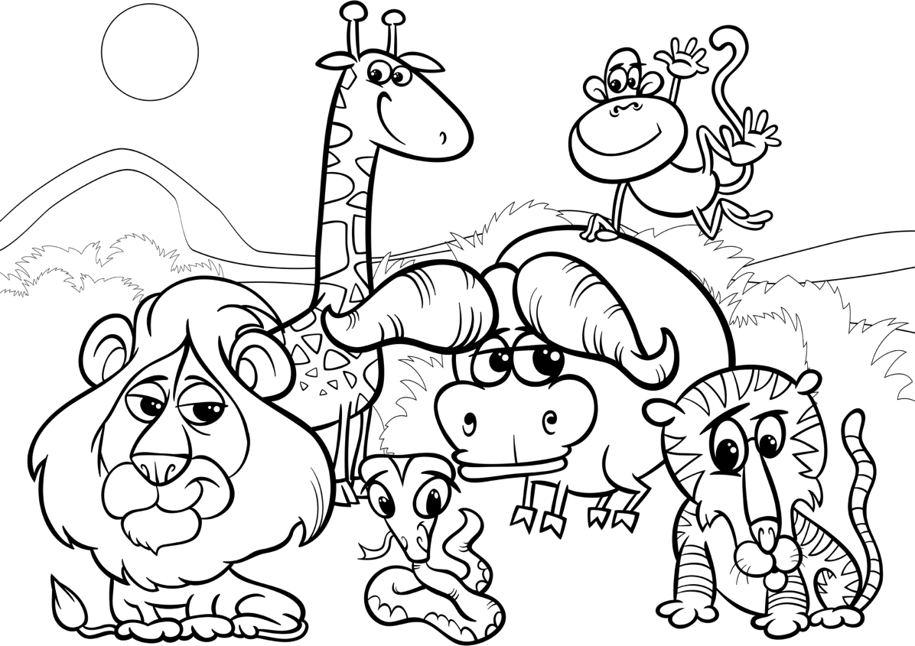

The Surprise
Gorilla--oowa, oowa, oowa
Tiger--growl
Laughing hyena--hee, hee, hee
Jungle Jim--Me, Jungle Gim
Animals-- (all make sounds)
Snakes--ssssssss

The animals---of the jungle had a meeting one special day.
The gorilla---who was in charge of this had something important to say.
The snakes---who usually crawled around, sat especially still.
For they wanted to hear what was going on up on Jungle Hill.
Seeba, the tiger---had arrived early at dawn.
And he was terribly upset 'cause he didn't know what was going on.
But the elephants and the lions thought perhaps this was about Jungle Jim---.
For it had been six days now since any animals---had seen him.
Now, you understand, growled the tiger---that we're here to prowl.
And find out where Jungle Jim--- is he said with a terrible gowl.
The laughing hyena---, and Seeba, the tiger---, and the snakes---thought about their homes.
For months ago, when the FIRE came, there was no where for them to roam.
If it hadn't been for Jungle Jim---, they wouldn't be able to live.
For he'd brought tiny trees and shrubs and to help the animals---did give.
Jungle Jim---cleared the jungle and worked both day and night.
And it wasn't too long before the animals---saw grass and trees growing to their delight.
The animals---remembered a she-human who was very, very fat.
Working hard, side by side, with their friend Jungle Jim---what do you think about that?
The animals---knew this she-human lived with him up on Jungle hill,
But why, asked the animals---were things so very, very still?
And so it was decided, the animals---would venture that night,
To jungle hill and see if they could tell if things were right.
The animals---crept carefully to the window open wide
And carefully, with caution, peeked to see what was inside.
The snakes---, the tiger---, the gorilla---. And the hyena---too,
Saw a sight, so strange, that night-they couldn't believe it true!!
There sat Jungle Jim---holding TWO HUMAN BABY CUBS, what a sight.
The animals---smiled, and watched the sight, "The Surprise" they discovered that night!
Why Gorillas Don't Have Tails
TAIL/TAILS ........ Place hand behind back and wave like a tail, and say “Swish, Swish”
GORILLA........... "Look at me"
ELEPHANT......... Use arms as trunk and make elephant trumpeting noise
PARROT.............. Arms as wings, "Caw, caw"
MONKEY............ Scratch sides, make monkey noises LION................... Shake head and roar
JUNGLE............. .All sounds and actions together

Did you know that long ago when the JUNGLE... was young, GORILLAS... were born with long, beautiful, bushy TAILS.... Their TAILS ... were more useful than the MONKEY'S... more expressive than the LION'S... more colorful than the PARROT'S... and stronger than an ELEPHANT'S... trunk.
That would've been okay with the rest of the JUNGLE... animals, too, except that the GORILLAS... were always showing off every chance they got. When the LIONS... were gently swaying their TAILS... so that all would know they were content, the GORILLAS... would sit next to them and make their TAILS... move in such a way that it looked like dancing.
When the MONKEY'S... would hang from the trees by their TAILS... so their hands and feet were free to peel bananas, the GORILLAS... would do them one better and actually peel their bananas with their TAILS... while they swung back and forth with their feet, teasing the MONKEYS...
When the ELEPHANTS... would work hard to lift a fallen tree from their path, the GORILLAS... would want to play tug-of-war with them, and of course, the ELEPHANTS... always lost to the superior strength of the GORILLAS'... TAILS...
The PARROTS... were tired of hearing about how gorgeous the GORILLA’S.... TAILS... were, after all, the colors of the PARROT... were very pretty, too. One PARROT... decided to trick the GORILLAS... Into hiding their TAILS...
He told all the other JUNGLE... animals that he had overheard the villagers planning to come and a steal the GORILLAS'... TAILS.. . Soon the story spread throughout the JUNGLE... to the GORILLAS... who took off their TAILS...and hid them deep in the JUNGLE...
From then on, whenever a LION... MONKEY... PARROT... or ELEPHANT... saw a GORILLA... with his TAIL... on, they would remind him of the villagers. And to this day, the GORILLAS... are still hiding their TAILS... much to the pleasure of all the other JUNGLE... animals. At least, that's the TALE... a PARROT... told me.

SONGS

Boa Constrictor
(Tune: “Battle Hymn of the Republic”)
I’m being eaten by a boa constrictor.
I’m being eaten by a boa constrictor.
I’m being eaten by a boa constrictor
And I don’t like it very much.
(Yelled) No
Oh no, oh no, he’s up to my toe
Oh no, oh no, he’s up to my toe
Oh no, oh no, he’s up to my toe
And I don’t like it very much.
(Yelled) No!
Oh gee, oh gee, he’s up to my knee.
Oh gee, oh gee, he’s up to my knee.
Oh gee, oh gee, he’s up to my knee.
And I don’t like it very much.
(Yelled) No!
Oh, fiddle, oh fiddle, he’s up to my middle.
Oh, fiddle, oh fiddle, he’s up to my middle.
Oh, fiddle, oh fiddle, he’s up to my middle.
And I don’t like it very much.
(Yelled) No!
Oh heck, oh heck, he’s up to my neck.
Oh heck, oh heck, he’s up to my neck.
Oh heck, oh heck, he’s up to my neck.
And I don’t like it very much.
(Yelled) No!
Oh dread, oh dread, he’s up to my head.
Oh dread, oh dread, he’s up to my head.
Oh dread, oh dread, he’s up to my head.
GULP!

Cub Scouts on the Trail
to the tune – Yankee Doodle
Our Cub Scout pack went on a trek,
A safari we were seeking.
The trails we climbed were steep and long,
The memories worth keeping.
Brave and fearless on the trail,
Loyal Cub Scouts, too.
Chart the course and keep in step
There’s lots of things to do.

Cub Scout Went on Safari
(Tune: The Bear Went Over the Mountain)
The Cub Scouts went on the safari,
the Cub Scouts went on a safari,
The Cub Scouts went on a safari,
to see what they could see.
The first thing they could see,
the first thing they could see,
Were a bunch of lions and zebras,
a bunch of lions and zebras,
A bunch of lions and zebras,
were the first things they would see.
The next sight that they saw,
the next sight that they saw
Was a tiger sharpening his long, sharp claws,
A tiger sharpening his long, sharp claws,
A tiger sharpening his long, sharp claws,
was all that they could see.
Their next exciting adventure,
their next exciting adventure,
Their next exciting adventure,
was watching an elephant herd.
And then they looked to the right,
and what an exciting sight,
There they saw a bunch of monkeys,
They saw a bunch of monkeys
They saw a bunch of monkeys, a swinging in the trees.

Elephants Have Wrinkles
(Tune: I'm a little Teapot)

Chorus:
Elephants have wrin-kles, wrin-kles, wrin- kles,
Elephants have wrin-kles, wrinkles everywhere.
Elephants have wrin-kles, wrin-kles, wrin- kles,
Elephants have wrin-kles, wrinkles everywhere.
On their toes,
No one knows, Why-y-y-y.

The Feet of the Hippo

(Tune: The Wheels on the Bus)

The feet of the hippo go thump, thump, thump, Thump, thump, thump, thump, thump, thump. The feet of the hippo go thump, thump, thump, All thru the day.

The nose of the hippo goes snort, snort, snort, Snort, snort, snort, snort, snort, snort.

The nose of the hippo goes snort, snort, snort, All thru the day.

The tail of the hippo goes swish, swish, swish, Swish, swish, swish, swish, swish, swish.

The tail of the hippo goes swish, swish, swish, All thru the day.

Try adding some other animals as well

Hippo

(Tune: Harrigan)

H - I - double P - O, is short for hippopotamus Nice and fat he's roaming the Savannah,

In the hot sun workin' on his tan-a.

H - I double P - O, is quite a guy you'll see, Loves to play all the day

Never one to stir up a fuss Hippopot - a - mus!!

In the Jungle
(The Lion Sleeps Tonight)
Divide the room in half with half doing the weemawehs
and the rest singing the verse
A-weema-weh, a-weema-weh, a-weema-weh, a-weema-weh
A-weema-weh, a-weema-weh, a-weema-weh, a-weema-weh
Clap on the “weem”
This part continues as the rest sing the verse
Snap fingers on the beat
In the jungle, the mighty jungle
The lion sleeps tonight
In the jungle, the mighty jungle
The lion sleeps tonight
A-wee-ee-eee, a-wee-um-uma-weh
Near the village, the peaceful village
The lion sleeps tonight
Near the village, the peaceful village
The lion sleeps tonight
A-wee-ee-eee, a-wee-um-uma-weh
Hush my darling, don't fear my darling
The lion sleeps tonight
Hush my darling, don't fear my darling
The lion sleeps tonight
A-wee-ee-eee, a-wee-um-uma-weh

Jungle Safari
Tune: “Frère Jacques”
In the jungle, in the jungle,
Look what’s here, look what’s here: Lions, tigers, oh my,
Giraffe reaching so high; Jungle time, jungle time.
On safari, on safari,
Way out there, way out there: Antelope and zebra, Wildebeest and monkey; Safari’s fun, safari’s fun.

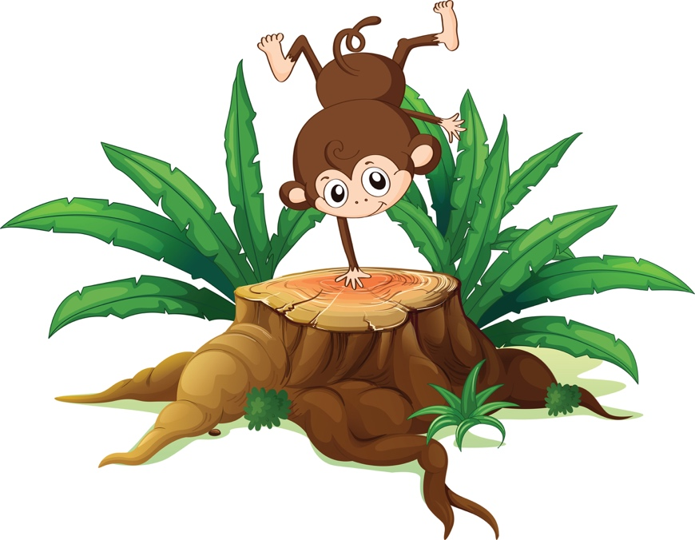
Jungle, Jungle, Safari
(Tune: Twinkle, Twinkle Little Star)
Jungle, Jungle, Safari
Far away in Africa
Kal-a-har-i Desert's hot
We trekked for miles, in the sun
Water, water, I need some
Sand for miles, this song is done.

Different version:
Jungle, Jungle, Safari
For adventure, it's the best
A Zam-be-zie River trip.
Ride in canoes, see the sights.
Saw the hippo, and the crocks,
Found the rapids,
Now I have to swim like a duck!

The Jungle Fair
(Tune: Animal Fair)

We went to the jungle fair.
The birds and the beasts were there.
The big baboon, by the light of the moon, Was combing his auburn hair.
The monkey fell out of his bunk,
And slid down the elephant’s trunk, whee! The elephant sneezed, and fell on his knees, And what became of the monk, the monk?
The Jungle Hokey Pokey
(Tune: Hokey-Pokey)

You put your Tiger foot in, you put your Tiger foot out, you put your Tiger foot in, and you shake it all about. You do the Hokey-Pokey and you turn yourself around. That’s what it’s all about.
(More verses: Monkey’s hand; Zebra tail; Giraffe’s neck; Toucan beak; Elephant’s trunk; Lion’s mane, etc.)

Jungle Song
(Tune: When Johnny Comes Marching Home)
The jungle Safari to us it calls
Hoorah! Hoorah!
With Tarzan, natives and animals.
Hoorah! Hoorah!
The Great White Hunter
who moves so slow
The Medicine Man of the Congo,
And we'll all be there
When the Jungle comes to call

Jungle Song
(Tune: My Bonnie)

Now this is the tale of the jungle, With Mowgli, the Wolves, and Baloo, The story was written by Kipling,
And some words in Cub Scouting came too.
Chorus:
Wolf, Bear, Akela
These words in Scouting came too, came too.
Wolf, Bear, Akela
These words in Cub Scouting came too.

Akela, that’s our Cubmaster
The Wolf and the Bear are Cub ranks. Cub Scouting was based on the jungle, And to Kipling we all give our thanks. CHORUS

Kooka Berra
Kooka Berra sits on the old gum tree
Merry, merry king of the bush is he.
Laugh, Kooka Berra laugh,
Kooka Berra, gay your life must be.

Long­Necked Giraffe

(Tune: Three Blind Mice)

Long-necked giraffe, long-necked giraffe,

You make me laugh, you make me laugh.

It’s true you can reach to the highest tree,

But it’s hard bending down to talk to me,

‘Cause your neck is too long for your body,

Long-necked giraffe.

Make Believe
(Tune: I’ve Been Working on the Railroad)

Let’s pretend we’re on a safari hunting lions and more,
Let’s pretend we’re in the jungle Seeking wild animals galore,
Or would you rather go sight-seeing While riding in a jeep east to west? No matter what we are pretending Our brains will meet the test.
It’s fun to make believe, It’s fun to make believe,
It’s fun to make believe and pretend. It’s fun to make believe,
It’s fun to make believe,
It’s fun no matter what our age.

Monkey See, Monkey Do
(Tune: Jingle Bells)

Monkey see, monkey do Just the same as you.
If you blink, then he will blink, He likes to copy you.
Monkey see, monkey do Just the same as you.
If you blink, then he will blink, He likes to copy you.

On Safari
(Tune: Found A Peanut)
On safari, on safari,
On safari yesterday
Yesterday, on safari,
On safari yesterday
Spied an elephant
Spied an elephant
Spied an elephant
Spied an elephant walking by
3. Heard a lion...roaring loud.
4. It stampeded...on my foot.
5. It crushed my toe..."ee ow"
6. Called doctor...Livingstone.
7. I was trekking...Africa.
8. Sent in Stanley...what a guy.
9. I can walk now...with a limp.
10. On Safari , On safari......

Safari field Trip
Tune: “I’ve Been Working on the Railroad”
Let’s pretend we’re on safari, Seeking lion and more.
Let’s pretend we’re in the jungle, With wild animals galore.
Or would you rather go sightseeing, in a jeep bound east to west?
No matter what we are pretending, our brains will meet the test.

It’s fun to make believe, it’s fun to make believe,
It’s fun to make believe and pretend. It’s fun to make believe,
It’s fun to make believe, No matter what our age.

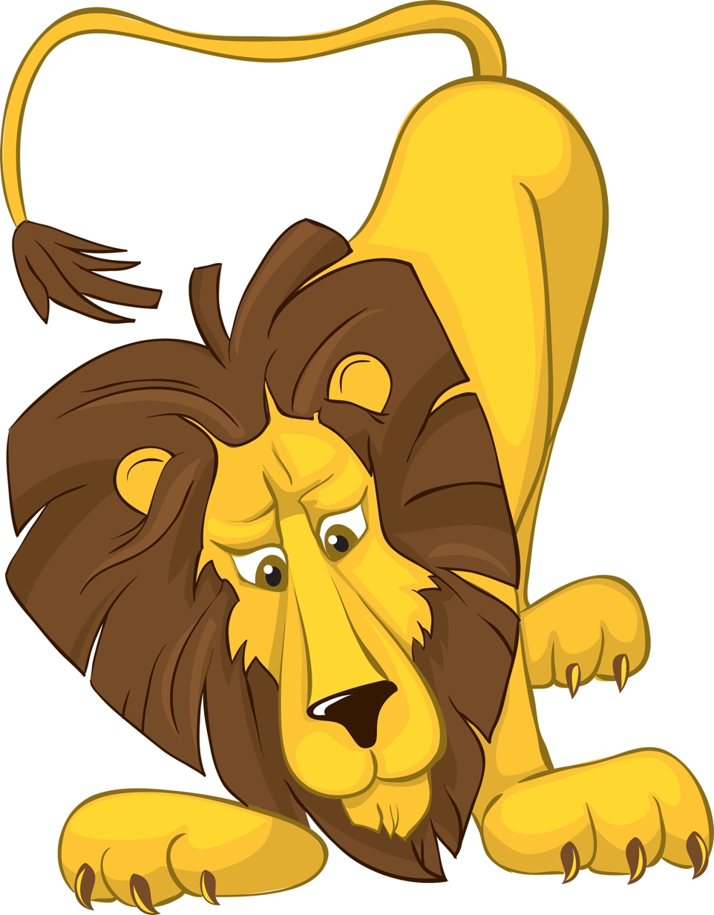
Safari
to the tune – If You’re Happy and You Know It
If you’re a Tiger and you know it,
Growl out loud
If you’re a Tiger and you know it,
Growl out loud
If you’re a Tiger and you know it,
Then your growl should really show it
If you’re a Tiger and you know it,
Growl out loud

If you’re a Wolf and you know it,
Howl out loud.
If you’re a Wolf and you know it,
Howl out loud.
If you’re a Wolf and you know it,
Then your howl should really show it
If you’re a Wolf and you know it,
Howl out loud.

If you’re a Bear and you know it,
Shake your paw.
If you’re a Bear and you know it,
Shake your paw.
If you’re a Bear and you know it,
Then your mighty claws should show it
If you’re a Bear and you know it,
Shake your paw.

If you’re a Webelos and you know it,
Shout Good Turn.
If you’re a Webelos and you know it,
Shout Good Turn.
If you’re a Webelos and you know it,
Then your helping hands should show it
If you’re a Webelos and you know it,
Shout Good Turn.

Safari Song
Tune: Alouette
Chorus
Safari, we trek on Safari
Safari, we learn about our world
First we see a lion pride
Tending to their young new cubs
Lion Pride - Young new cubs
OOOooohhh
Chorus
Next we see a tall giraffe
Eating from the tops of trees
Tall giraffe – Tops of trees
Lion Pride - Young new cubs
OOOooohhh
Chorus
Up ahead a zebra herd
Are their stripes black or white?
Zebra herd – Black or white
Tall giraffe – Tops of trees
Lion Pride - Young new cubs
OOOooohhh
Chorus
Here is a gorilla troop
See them picking some fresh fruit
Gorilla troop - some fresh fruit
Zebra herd – Black or white
Tall giraffe – Tops of trees
Lion Pride - Young new cubs
OOOooohhh
Chorus
Look I see an elephant
He sprays his back with dirt
Elephant - back with dirt
Gorilla troop - some fresh fruit
Zebra herd – Black or white
Tall giraffe – Tops of trees
Lion Pride - Young new cubs
OOOooohhh
Chorus
Look quick to see the cheetah's spots
Cheetahs are the fastest cats
Cheetah spots - fastest cats
Elephant - back with dirt
Gorilla troop - some fresh fruit
Zebra herd – Black or white
Tall giraffe – Tops of trees
Lion Pride - Young new cubs
OOOooohhh
When we see the town ahead
Then we know our trek is done
Town ahead – TREK IS DONE!

Song of my Shoes
(Tune: Battle Hymn of the Republic)
My shoes have seen the glory of the growing of a Scout.
My shoes have been in water steppin' in and steppin' out.
My shoes have hiked through forest to the top of the mount;
My shoes are wearing out!
Chorus
Groovy, Radical, and Awesome (repeat 3x)
My shoes are wearing out!
My shoes have seen the bottom of the dirty fishy creek,
My shoes have been all covered with the gooey, muddy cake,
My shoes have seen the same old socks for seven days this week,
My shoes do really stink!
Chorus
Groovy, Radical, and Awesome (repeat 3x)
My shoes do really stink!
My shoes are torn and tattered climbing fences packed in rust,
My shoes are stained and spattered with some yucky insect guts,
My shoes are oozing slime and fill my Mom with disgust,
My shoes have bit the dust!
Chorus
Groovy, Radical, and Awesome (repeat 3x)
My shoes have bit the dust!

Take Me Out to The Forest
(Tune: Take Me Out to The Ballgame)

Take me out to the forest. Let me hike in the wild.
Show me a skunk and a few bear tracks. I won't care if I never come back.
But it's look, look, at your compass. If it rains, then your wet.
And its ouch, slap, sting and you're bit in the great outdoors.

Take me out to the Jungle
Sung to the tune of “Take Me Out to the Ball Game”
Take me out to the jungle
Let me walk in the weeds.
Hiking the trails lined with tow’ering trees
Flowers abloom in the high climbing vines
We’ll seek bugs, birds and monkeys,
Magpies, fly’s and snakes.
Many things we will I-den-ti-fy
On our jungle tour!

Tarzan of the Apes
(Tune: Battle Hymn of the Republic)
I like bananas, coconuts and grapes.
I like bananas, coconuts and grapes.
I like bananas, coconuts and grapes,
That’s why they call me Tarzan of the Apes! UGH!!!
Repeat three times -
First time - very loud
Second time - normal voice
Third time - whisper
But each time yell Tarzan of the Apes! UGH!!!

The Coming of the Frogs
(Tune: Battle Hymn of the Republic)
Mine eyes have seen the horror of the coming of the frogs,
They are sneaking thru the swamps and they are lurking in the logs.
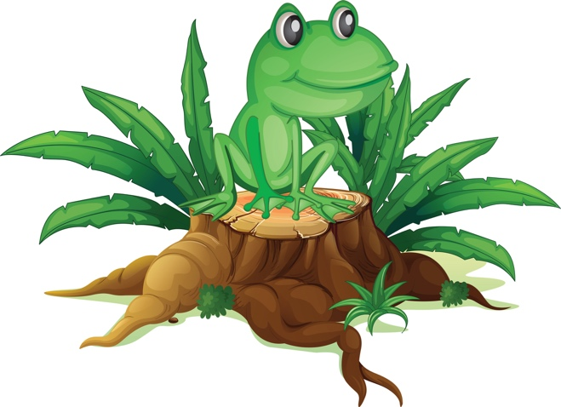
You can hear their mournful croaking through the early morning fog.
The frogs keep hopping on.

Chorus: (repeat after each verse)
Ribet, ribet, ribet, croak, croak.
Ribet, ribet, ribet, croak, croak.
Ribet, ribet, ribet, croak, croak.
The frogs keep hopping on.

The frogs have grown in numbers and their croaking fills the air.
There's no place to excape because the frogs are everywhere.
They've eaten all the flies and now they're hungry as a bear
The frogs keep hopping on. Chorus

They've hopped into the living room and headed down the hall,
They have trapped me in the corner and my back's against the wall.
And when I opened up my mouth to give the warning call,
This was all I heard. Chorus

The Tree Toad
(Tune: Auld Lang Syne)
A tree toad loved a fair she toad
That lived up in a tree.
She was a fair three-toed tree toad,
But a two-toed tree toad was he.
The two-toed tree toad tried to win
The she toad's friendly nod;
For the two-toed tree toad loved the ground
That the three-toed tree toad trod.
Now three-toed tree toads have no care
For two-toed tree toad love.
But the two-toed tree toad fain would share
A tree home up above.
In vain the two-toes tree toad tried;
He could not please her whim.
In her tree toad bower with her veto power,
The she toad vetoed him.

Where has our Safari Guide Gone?
(Tune: Where, oh Where, Has Our Little Dog Gone)

Oh where, oh where, has our Safari guide gone,

Oh where, oh where can he be?

With the map and gun he was on the run 'Cause a rhino chased him up a tree!

RUN-ONS

Cub Scout Jungle Cheer
Cubmaster: Here we are in the jungle is everyone here, Tiger Cubs stand up and cheer.
Tiger Cubs: (Growling, stand up) (Cheer)
Cubmaster: Here we are in the jungle is everyone here, Wolf Cubs stand up and cheer.
Wolf Cubs: (Howling, stand up) (Cheer)
Cubmaster: Here we are in the jungle is everyone here, Bear Cubs stand up and cheer.
Bear Cubs: (Growling, stand up) (Cheer)
Cubmaster: Here we are in the jungle is everyone here, Webelos stand up and cheer
Webelos: (Stand up and give Cub Scout Salute) "We'll Be Loyal Scouts."
Cubmaster: Here we are in the jungle is everyone here, Akela stand up and cheer.
Leaders and Parents: (Stand up) (Cheer)
Cubmaster: Here we are all, in the jungle, Akela lead us safely on.
All: (Repeat their cheer)

DEN YELLS
Yell 1: 2, 4, 6, 8,
Jungle Adventure we can’t wait,
(Make an animal sound)

Yell 2: Jungle Adventure here we come,
Den ___, Den ___ ,
Is # one!

Yell 3: On a safari we shall go, What will we see?
No one knows!
Go Den ___!

Yell 4: Lions, Tigers, Cheetahs too,
Den ___, Den ___,
Here’s looking at you!

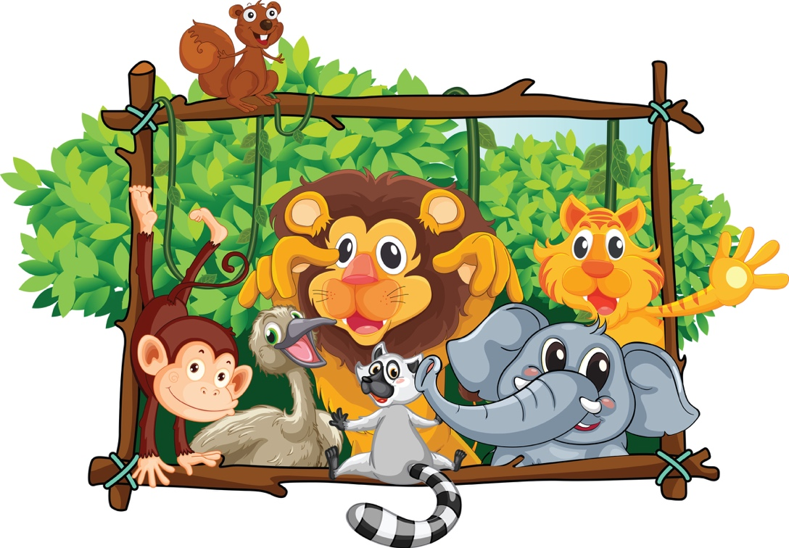

RUN-ONS
#1: What did the mother turtle say to her baby turtle?
#2: You should come out of your shell!

#1: What does a snake wear with a tuxedo?
#2: A BOA tie!

#1: What wild animals are best dressed?
#2: TIE-gers!

#1: Which side of a cheetah has the most spots?
#2: The outside, of course!

#1: What do elephants do for fun?
#2: They tell “people” jokes!

#1: What do you get when you cross a parrot with a centipede?
#2: A walkie talkie!

#1: What is a crocodile’s favorite game?
#2: That’s simple – SNAP!

#1: What’s the difference between a hurt lion and a wet day?
#2: One pours with rain, the other Roars With Pain!

#1: What time is it when an elephant sits on your fence?
#2: Time to get a new fence!

#1: Where do wild animals play?
#2: On the jungle gym!

#1: Why are you wearing that green string?
#2: To keep the lions away.
#1: But there are no lions around here.
#2: See how well it works?

#1: How can you lift an elephant?
#2: Put an acorn under him and wait twenty years.

#1: What business did the father ape want his son to go into?
#2: The monkey business!

#1: I’m a great jumper
#2: I can jump too. I bet I can jump higher than that tree.
#1: This I gotta see. (jumps a little hop)
#2: That’s higher than a tree?
#1: Sure, that tree can’t jump at all.

#1: What’s the best year for a kangaroo?
#2: Leap year!

#1: (runs in yelling) They’re after me! They’re after me!
#2: Who’s after you?
#1: The monkeys! They think I’m bananas!

#1: Can you name 9 animals from Africa?
#2: Sure, 8 elephants and a lion.

#1: Hello, operator. I’d like to speak to the King of the Jungle.
#2: I’m sorry sir, but the lion is busy.

#1: What’s worse than a giraffe with a sore throat?
#2: That’s a hard one.
#1: A centipede with athlete’s foot.

#1: Why can’t you get two elephants into a pool at the same time?
#2: They only have one pair of trunks.

#1: What do you get when you cross a tiger with a parrot?
#2: I don’t know, what?
#1: I don’t know either, but when it talks, you better listen!

#1: Ask me if I’m a rabbit.
#2: Okay. Are you a rabbit?
#1: Yes. Now ask me if I’m a beaver.
#2: Are you a beaver?
#1: No silly. I already told you I was a rabbit.

# 1: Did you hear about the tiger who ate a lemon?
# 2: No, what about him?
# 1: He became a sour puss.

# 1: Do you know why lions roar?
# 2: Of course. Because they would feel silly saying, “Oink!”

# 1: I just spotted a leopard.
# 2: Don’t be silly they grow that way.

# 1: What do you get when you cross an ape with a tiger?
# 2: Tarzan stripes forever.
# 1: What do you do with a blue elephant?
# 2: Cheer him up.
# 1: I saw some panther tracks about a mile east.
# 2: Good, which way is west?
# 1: Did you have any luck hunting tigers?
# 2: Yes, I didn’t meet one!
# 1: Why are you wearing that green string around your finger?
# 2: To keep the lions away.
# 1: But there are no lions around here.
# 2: See how well it works?

# 1: How do you know when an elephant likes you?
# 2: It gives you a stamp of approval.
# 1: How fast must you run if a tiger is chasing you?
# 2: One step faster than the tiger.
# 1: Why do elephant walk so slowly?
# 2: Because they don’t have jogging shoes.

# 1: What did the cheetah say after he ate an ice cream cone?
# 2: That hit the spot!
# 1: What goes through the jungle without making a sound?
# 2: A trail.
# 1: What kind of animal eats with his tail?
# 2: All kinds. They can’t take them off.
# 1: Why does a giraffe eat so little?
# 2: He makes a little go a long way.

# 1: Where do wild animals like to play?
# 2: On the jungle gym

# 1: With what big cat should you never play cards?
# 2: The cheetah!

# 1: Why do elephants paint their toenails red ?
# 2: So they can't be seen when they hide in cherry trees.

# 1: How do you know you have had elephants in the fridge?
# 2: Footprints in the butter.

# 1: How do you get two elephants in a pickup truck?
# 2: One in the cab, one in the back.

# 1: How do you get two mice in a pickup truck?
# 2: You can't ... it's full up with the elephants.

# 1: Why do Rhino’s wear ripple‐soled sneakers?
# 2: To give the ants a chance

Safari Knock Knock
#1: Knock Knock…Who's there !
#2: Safari !...Safari who ?
#1: Safari so good !

#1: Knock Knock…Who’s there?
#2: Fashion….Fashion who?
#1: Fashion your seat belt – we’re going on a great ride!

#1: Knock Knock…Who’s there?
#2: Owlet….Owlet who?
#1: Owlet you go first through the jungle!

SKITS

All About Animals Skit
Cast: Jerry, Jimmy, Johnny and Jack.
Scene: Jerry is reading. He turns the pages of his book slowly, one by one as the others enter.
Jimmy: Hi, Jerry. What are you doing?
Jerry: (Not looking up) Reading a book about animals.
Jimmy: It must be a good book. (He sits down and picks up a book and starts reading.)
Johnny: (Enters) Hi, Jerry. What are you doing?
Jerry: (Not looking up) Reading this book. (Closes book) Now I know all about animals.
Jack: (Enters) Hi, guys. What are you doing?
Johnny: Jerry’s been reading this book. He says he knows all about animals.
Jack: Okay then, tell me, what animal can jump higher than the Empire State Building?
Jerry: (Thinks) I’ll have to look it up. (He looks in book)
Jimmy: I don’t think any animal can jump higher than the Empire State Building.
Johnny: (To Jerry) And I thought you knew all about animals!
Jerry: (Sheepishly) So did I. So, what animal can jump higher than the Empire State Building?
Jack: All of them. The Empire State Building can’t jump!

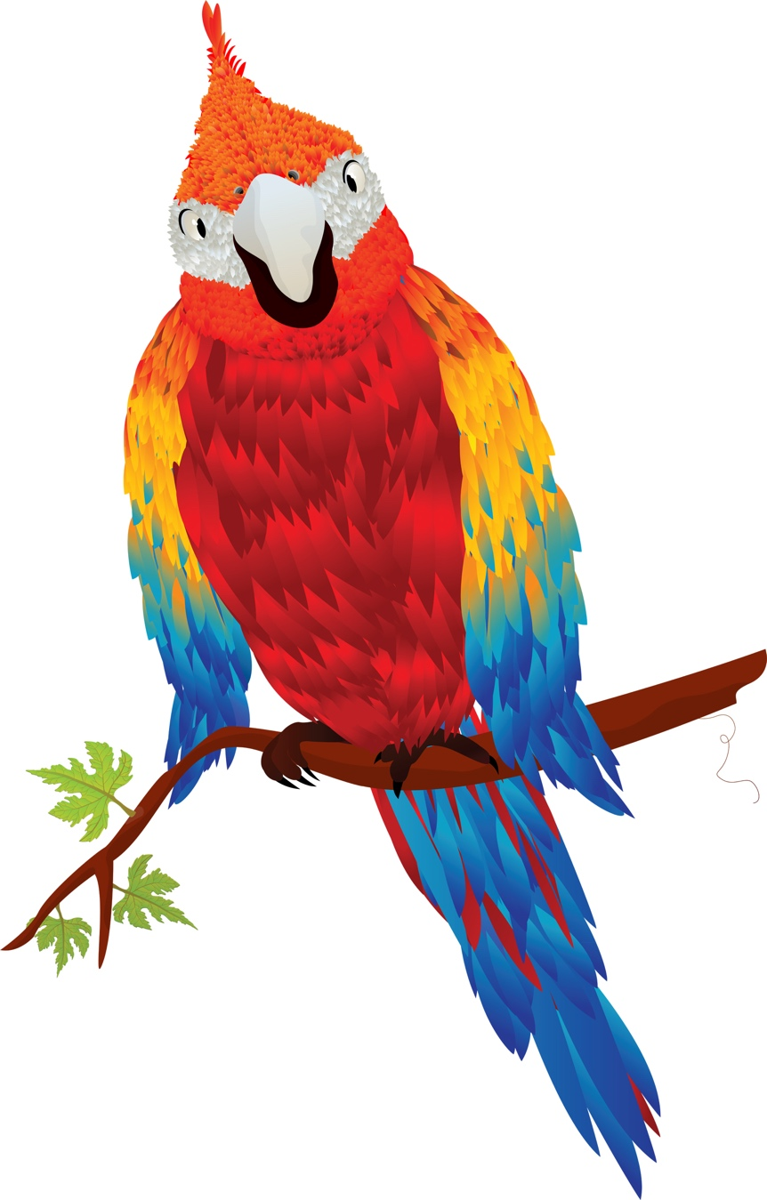

Cub Scout Safari
Set-up: 5 Scouts and Camp Director driving a cardboard jeep with safari hats on
CD: We're so glad you could join us on our jungle adventure tonight. Our fearless leader (CD's name) will be driving our jeep. But as with any trip there are a few instructions you must hear. (2 Cub Scouts jump out of the jeep and start chasing each other)
1st passenger still in jeep: “Johnny Lion, what are you doing?” One of the Cub Scouts running: “I'm chasing a hunter around a tree.”
2nd passenger still in jeep: “How many times have I told you not to play with your food.” (All go back to jeep)
Next Cub Scout gets out of jeep and says:
“Bobby had a kitten, Tommy had a pup, Johnny had a crocodile, That ate the others up.”
3rd passenger (climbs out of jeep and looks at the 4th passenger): “What has fifty legs, big blue eyes on stems, and a red body with green stripes?”
4th passenger: “I don't know. What?”
CD: “I don't know either, but it's crawling up your shirt right now.”

Cub Scout Safari Skit
These puppet patterns can be enlarged to make life-size, or at least Cub-sized “costumes” cut out of cardboard. Circles shown are cut out for the Cub Scout’s head and arms, about elbow height. Cub Scouts can then paint them to wear in the skit, during run-ons, or as they give a “bio” of who they are, where they live, what they eat, who eats them, and how they protect themselves.
For younger Cub Scouts, you could have the Cub Scout say only the underlined part and the narrator could fill in the rest.

Narrator: This month, the Cub Scouts from our pack went on a real adventure – an animal safari. Who’s this first animal?
Hippo: I live in the water and on land – I don’t really swim, but I spend much of my time in the water, walking along the bottom. I am the most dangerous animal in Africa for humans. I’m the hippo and I can hold my breath longer than any other animal on safari.
Giraffe: Personally, I like to get above everyone else. My long neck lets me eat the most tender leaves from the very top of the tallest trees. I may not look very graceful when I bend to get water, but I can cover lots of ground with my long legs – and deliver a dangerous kick. My neck is so long that it has to sway as I run to keep my balance – I’m the giraffe.
Cheetah: I can run much faster than the giraffe – in fact, I’m the fastest animal in the world. – the cheetah. But antelope often escape because they can run for longer times than I can. Even lions are afraid of me if they have young cubs.
Lion: I am still the King of the Jungle, the lion. I can blend right in to the grasses where I live, and walk softly and slowly without my prey even knowing I am coming close. Actually, I just watch as the females run down my dinner for me! Like all cats, I love to sleep and rest for about 20 hours a day!
Elephant: I am so heavy and strong that my Indian cousins are used to haul people and very heavy loads-I’m the elephant. In the jungle, I uproot whole trees to get at the food I like best. I can use my trunk, which has many muscles, to pick up small items. But my sound is not small – the loud trumpet sound I make can be heard for miles.
Chimpanzee: You may have seen me in a zoo, and laughed at the funny faces I sometimes make – I’m the chimpanzee. In the jungle, I live in a large family group and take turns grooming my friends. I’m really clever – I put a stick into an anthole, and when the ants climb on, I pull out the stick and eat them.
Zebra: I may look like a horse to you, but I’m the zebra, and my stripes have a special purpose. Each species of zebra has a different pattern of stripes, and the black and white colors blend into shadows, helping me hide from my enemies. I can also kick and bite in a fight.
Narrator: Well, our Cub Scouts certainly “captured” a lot of jungle animals on their safari this month. Each one has a special place in the jungle – the variety is wonderful. Some of these animals are endangered by over-hunting and loss of habitat. Let’s encourage humans all over the world to do their part to keep our safari animals safe!

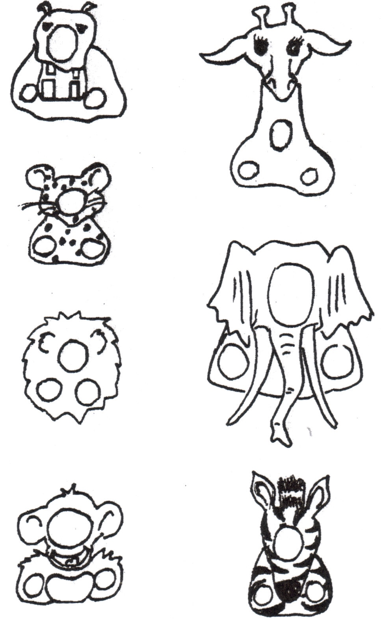
Did You See That? Skit - Classic Version
Stanley, (In a strong European accent) Hello there, I am Arthur Stanley Livingstone, the world famous ornithoptitologist! That means I watch birds, you know. And we are all going on a bird study trip today
All: (Not really paying attention) H'lo
Stanley We are here today on location in the midst of the African rain forest, and we should see some very rare birds indeed! I can hardly contain myself. It is so exciting isn’t it?
#1: Oh. Uh, yeah
Stanley slowly and carefully stalks along, looking around,
listening for the slightest peep. Cub Scouts shuffle after him.
Stanley, (Turning around, staring with wide open eyes for a second, then jumping up and down)
Did you see that!! Did you see that!!
#1 - Er, what?
Stanley You mean you missed it?
#1, (Pauses, then admits it) Uh, yeah
Stanley "Well! My word. Todd, that was a very rare bird, the Oohweeoo-plit-plit-plit-awaah. And you missed it. It's named after it's call, you know."
#1 Mmm, what's it sound like?
Stanley, (After a suspenseful pause) Peep!
Stanley continues his slow stalking and looking around,
Cub Scouts follow after him.
Stanley, (Stopping and looking up wide-eyed. Cub Scouts walk into him). Did you see that!! Did you see that!!!
#2 Er, um, well
Stanley, (Somewhat cross) Well?
#2 No
Stanley, (After a long sigh) Now that, my dear Cub Scout, was an Ooh-Aah bird. Have you heard of the Ooh-Aah bird?
#2 No
Stanley The Ooh-ahh bird, is a three-pound bird that lays a four-pound egg. (Pantomime the egg-laying process "Oooooooooooh .. ahhhhhhhhhh!!!")
Stanley and Cub Scouts continue their pacing about the stage
(if you wish, make up some more items for other Cub Scouts)
Stanley, (Turning around and yelling at # 3)
Did you see that!! Did you see that!!!
#3, (Deciding to be clever)
Er, um, ah, yes! Yes, I did see that!
Stanley Then why in the blazes did you step in it?
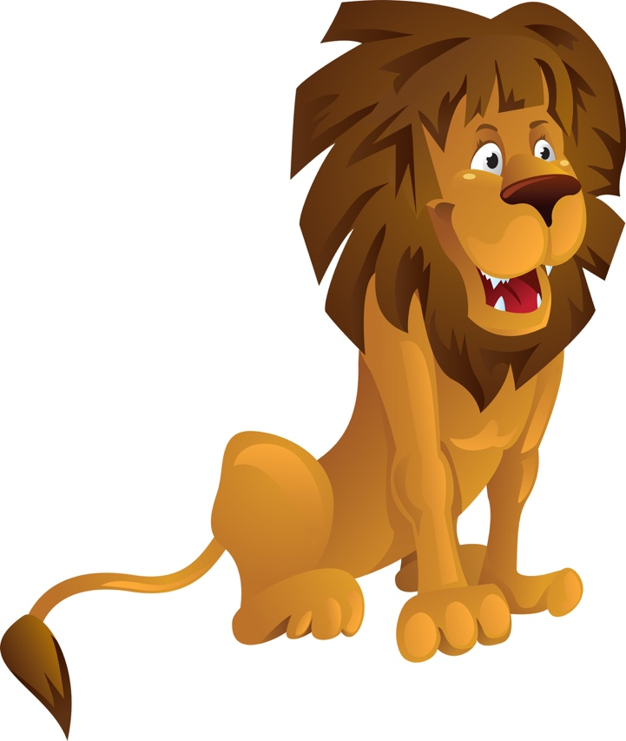

Did You See That? Skit
Here are some ideas for other animals -
Parrot - who can imitate our voices
Eagles - the symbol of America
Lion - the king of the beast
Hippo - the water horse
Stanley (in a strong European accent) Hello there, I am Arthur Stanley Livingstone, the world famous explorer And we are all going on a photographic safari today.
Cub Scouts not really paying attention "H'lo"
Stanley "We are here today on location in the midst of the African rain forest, and we should see some rare species indeed! I can hardly contain myself. It is so exciting isn’t it?
Cub Scouts "Oh. Uh, yeah."
Stanley slowly, carefully stalks along, looking around, listening for the slightest peep. Cub Scouts shuffle after him.
Stanley, turning around, staring with wide open eyes for a second, then jumping up and down "Did you see that!! Did you see that!!"
#1 - "Er, what"
Stanley "You mean you missed it?"
#1, (pauses, then admits it_ "uh, yeah"
Stanley "Well! My word. Todd, that was a Tamarin Monkey. They are very rare, in fact two species, The golden Lion and the Cotton Top are on the endangered species list
Stanley continues his slow stalking and looking around, Cub Scouts follow after him.
Stanley (stopping and looking up wide-eye). Cub Scouts walk into him. "Did you see that!! Did you see that!!!"
#2 "Er, um, well"
Stanley, (somewhat cross) "Well?"
#2 "No."
Stanley (after a long sigh) "Now that, my dear boy, was a Toucan with his bright yellow beak. They are very noisy and often sound like a frog croaking.
Stanley continues his slow stalking and looking around, Cub Scouts follow after him.
Stanley, stopping and looking up wide-eyed. Cub Scouts walk into him. "Did you see that!! Did you see that!!!"
#3 "Er, um, well"
Stanley, "Well?"
#3 "No."
Stanley (after a long sigh) "Now that, my dear boy, was a Malay Fruit Bat. It is rare to see them in daylight. They usually only travel at night using their personal sonar to avoid flying into trees and stuff.
Stanley and Cub Scouts continue their pacing about the stage (make up some more items for other Cub Scouts)
Stanley (turning around and yelling at # 3) "Did you see that!! Did you see that!!!"
#3 (deciding to be cleve)r "Er, um, ah, yes! Yes, I did see that!"
Stanley "Then why in the blazes did you step in it?"
I can Lick 10 Lions Skit
Narrator (does all the talking while hunter and lions act out the parts)

Lion Costume: Fringe material or crepe paper to put around face of lions. A tail could be hooked on the back at the waist.

(Hunter flexes muscles) I feel great! Simple great!
I can lick 10 lions today. (10 lions appear)
Well, maybe only nine.
Will you please step out of line? (One lion leaves)
I can lick 9 lions today. (Lions come closer)
Well, that's sort of a mean thing to do.
I'll cut my list.
First one dismissed. (One leaves)
I'll beat up the next eight.
I can lick 8 lions today. (Lions move closer)
Well---maybe just seven.
You, in the front row. You're excused.
You may go. (One lion leaves)
Your fingernails aren't very clean. (Points to another)
I can lick 6 lions today.
Well---quite a few of you are underweight.
It's not fair, after all, to lick lions so small.
I think that I'll only lick 5.
I can lick 5 lions today.
Well, you look sort of sleepy to me.
Some of you chaps should go home and take naps.
I only intend to lick 4. (One leaves).
I can lick 4 big lions today.
Well, it's frightfully hot in the sun.
You two, I'm afraid should be down in the shade (Two leave).
I can lick two lions today.
Two lions would make such a little fight. (One leaves)
I can lick one lion today.

Lion: Grrrr. Grrrrr.

Narrator: But you know I have sort of a hunch that noontime is near. You just wait for me here. I'll beat you up right after lunch.

(Lion chases hunter off stage).

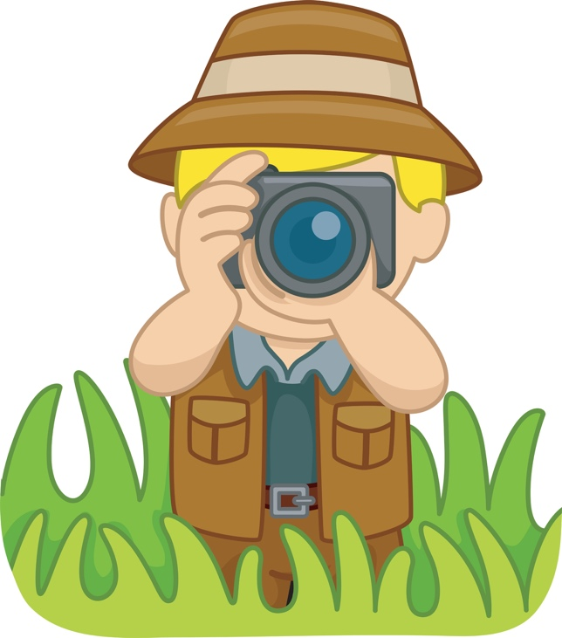

The Lost Pet
(This skit can also be played by one person by wearing two different hats and crouching as a Cub Scout and looking downward as a man.)
Cub Scout: (Enter crying, dragging a dog leash) Waaaaaah! Waaaaaah! Man: Little Cub Scout, what’s the matter?
Cub Scout: My pet ran away! Waaaaaah!
Man: Don’t cry, little Cub Scout. I’ll help you find it. What color is your pet? Cub Scout: Yellow, with black stripes. Waaaaaah!
Man: Don’t cry, little man, I’ll have your pet back in no time. (Search about the stage, muttering to self) Yellow with black stripes...hmmm... Cub Scout: I want my pet! Waaaaaah!
Man: Maybe he wandered down the street. You just wait here while I go look for him.
(Exit, quickly put on a ragged coat, muss up hair. Enter, running, shouting) Why didn’t you say it was a TIGER? (Exit, running.)

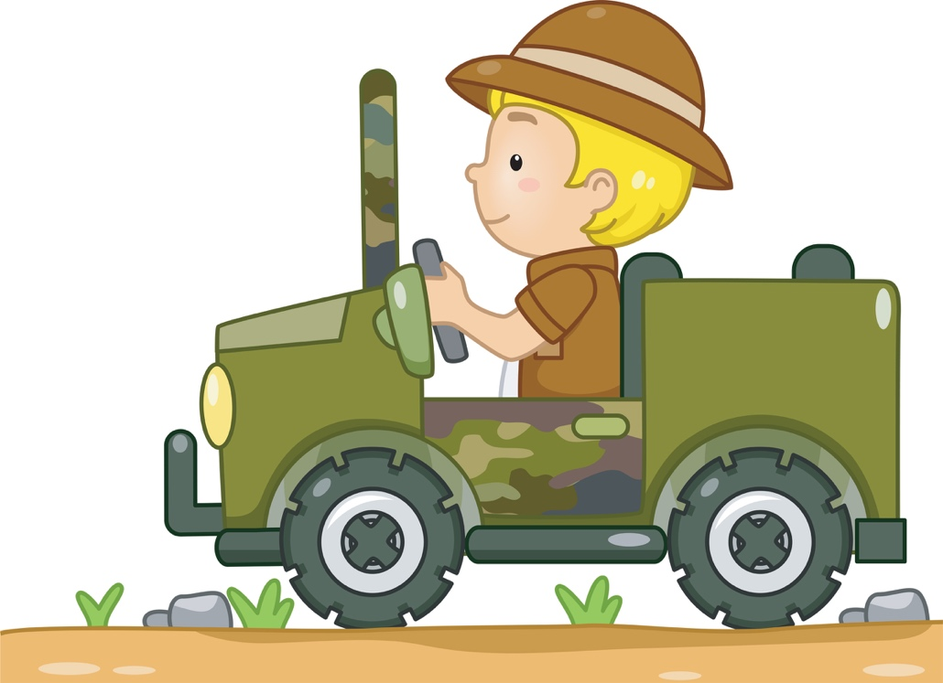
A Jungle Book Skit
Setting: Lights out, artificial fire, spotlight, 3 Scouts around the campfire.
#1: The forest is quite beautiful tonight, filled with friends and danger.
#2: Yes, it reminds me of a book I read as a boy, “The Jungle Book,” by Rudyard Kipling.
#1: I think I remember that book. Wasn’t that the story of a lost boy adopted by a wolf pack?
#2: Yes, the wolves named him Mowgli, meaning “Little Frog,” because his skin was smooth and hairless.
#3: How did Mowgli come to live among the wolves?
#2: He wandered away while Shere Khan was terrifying his village.
#3: Who is Shere Khan?
#2: Shere Khan was the great tiger bully—all stripes, teeth, and claws—and, like most bullies, not very brave when confronted.
#3: Was Mowgli immediately accepted into the wolf pack?
#2: No, Mowgli, the man-cub, had to get the approval of the pack and Akela. Two animals had to speak up for him.
#3: Who is Akela?
#2: Akela was the wise old wolf – the head of the pack. He saw that the younger wolves all kept the Scout Law.
#3: What animals spoke up for Mowgli?
#2: The first to speak was Baloo, the serious old bear who taught young wolves the Scout Law. The second was Bagheera, the cunning black panther, who taught the skills of the pack.
#3: Were there other animals in the story?
#2: Yes, there was Hathi, the elephant, and the Bandor-log.
#3: The Bandor-log?
#2: Yes, the Bandor-log were the monkey people. They obeyed no laws. They were not brave; they fought only if they greatly outnumbered their foes.
#3: Any other animals?
#2: There was Tabaqui, the dish licker—the mean, sneaky jackal who made friends by using flattery so he could get food from them. And there Kaa, the great serpent, who appeared slow and good-natured; but, anyone who joined the Bandor-log was soon swallowed up by Kaa. Some say his real name is Laziness.
#1: You know Lord Baden-Powell used “The Jungle Book” as the basis of Cub Scouts.
#3: I never knew that.
#1: Well, it’s true. There were many kids wanting a program that were too young for Boy Scouts. Baden-Powell called them “Wolf Cubs.” Boy Scouts were called wolves after the Indian name for Scout. And young Scouts are young Wolf cubs.
#3: What things did Baden-Powell use from the Jungle Book?
#2: The Scout Oath is like the wolf’s solemn promise, and the Scout Law is like the law of the jungle. Even the two fingers of the Cub Scout sign represent the two ears of the wolf. Many Cub Scout ceremonies and patches still show their “Jungle Book” origins.
#3: Aha—so that is how Cub Scouting was started.

Magic Mud Skit
Setting – 7 Scouts
Scene – Sign in center of stage is marked “Mud Puddle.” Scouts enter and gather around the sign.
#1: Did you ever wonder as you pass a little stretch of mud and grass what nature may be hiding there, within this spot of a few feet square? Let’s gather around and take a look and like the pages in a book, we’ll study it with open eyes. Can mud like this hold any surprises?
#2: Here is a freshly patterned animal track, where a rabbit hopped across and back.
#3: I see a line of busy ants, carrying tidbits of food upon their backs.
#4: Look, I found a feather that’s blue and gray, probably from a low flying blue jay.
#5: Sprinkled here are signs of sprouting seeds from lofty trees and sprawling weeds.
#6: A pebble smoothed by nature’s action slow, formed a million years ago.
#7: In a puddle spot not yet dried out, a water beetle swims about.
#2: And here an eager plant is set – an early blooming violet.
#3: A wiggly worm come up to twitch, how do we tell which end is which?
#4: The mud itself with food stores vast, from life that flew in ages past.
#5: It’s not all nurture mud reveals. Here’s a candy wrapper and two toy wheels.
#6: There’s something moving – what’s that now? I’ll pick it up, a Bee, YOW!
#7: Quick, here’s some mud upon the spot, to take away the soreness hot.
#1: In mud there’s stone and living things, healing power for bitter stings. Through it flows the earth’s life blood; our mud is really Magic Mud!

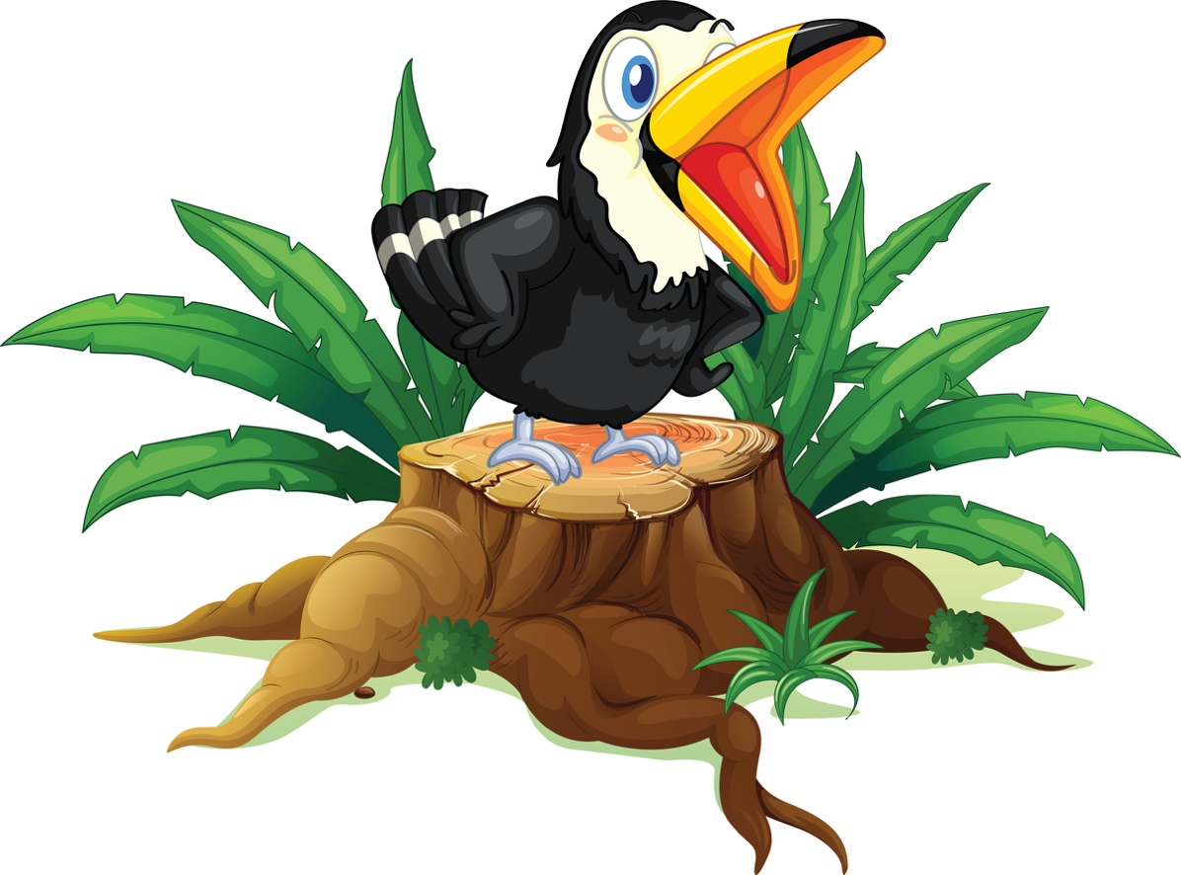
We're Going On Safari
This is an action chant, which can be performed by as many Cub Scouts as you wish. It can be made into something really good, by dressing up in safari gear and carrying rifles.

#1: We're going on safari.
All: We're going on safari.
#1: We're gonna catch a big one.
All: We're gonna catch a big one.
#1: Ooh look a snake.
All: Ooh look a snake.
#1: Hiss, hiss.
All: Hiss, hiss.

#2: We're going on safari.
All: We're going on safari.
#2: We're gonna catch a big one.
All: We're gonna catch a big one.
#2: Ooh look a crocodile.
All: Ooh look a crocodile.
#2: Snap, snap.
All: Snap, snap.
#1: Hiss, hiss.
All: Hiss, hiss.

#3: We're going on safari.
All: We're going on safari.
#3: We're gonna catch a big one.
All: We're gonna catch a big one.
#3: Ooh look a panther.
All: Ooh look a panther.
#3: Poof, poof.
All: POOF, POOF.......Why on Earth poof poof?
#3: Well, he was pink!
#2: Snap, snap.
All: Snap, snap.
#1: Hiss, hiss.
All: Hiss, hiss.

AND SO ON.

To finish you can have someone dressed in a gorilla suit. The last scout starts to sing ooh look a gorilla, then all the others see the gorilla as he comes on stage and chases them all off screaming.

GAMES

Animal Relays
Use one of the animal walks found in Bear Achievement 16c or make up one of your own to run a relay.
Use a combination of walks to make it more challenging.
Let the Cub Scouts help plan the relay.

At the Watering Hole
- This is a large group activity and can be played inside or outside.
- Divide into small groups of 4-5 players, who must turn into animals with only 6 legs, but every player must be making part of the animal.
- The “animal” must be able to walk to the “watering hole” (a bowl with water in it) and drink from it, with only 6 legs touching the ground.
- Players can do a piggy-back, wheelbarrow, or even limp on one leg, as long as their animal can walk and drink.

Barrel of Monkeys
- Open several paper clips and place on a flat surface or in a large open container.
- Holding onto one paper clip catch another, and another, and so on.
- See how many the Cub Scouts can catch in a certain amount of time.

Barrel Full of Paper Clip Monkeys
Materials: Large colored paper clips, a jar or tub or mug
- Unfold/bend the paper clips into long S shapes and place in jar.
- Each player then dumps the “monkeys” into a pile, and, holding just one, tries to make the longest string by hooking others.
- When the string breaks, it’s the next player’s turn.

Cobra Connection
- All the Cub Scouts form a line, representing a jungle snake.
- Each Cub Scout kneels down and grabs the ankles of the person in front of him.
- On the leader’s signal, the entire group must move forward together – especially fun to do outdoors – try even ground, or even try to navigate some hills or obstacles.
- If there are enough Cub Scouts, form two teams, and have a “race” over a duplicate course, or do it one team at a time and use a stop watch to select the winning team.

Creating Creatures
Divide the group into teams of 3 or 4. Give each team a pair of scissors, glue, and a variety of colors of construction paper. Within a given time limit (15 minutes) each group designs and constructs a jungle animal from the jungle. They must decide on a name for their animal, tell where it lives and what it eats. When all teams are finished, a spokesman for each team introduces their animal to everyone.
Cub Scout Safari
This would be a fun one to do in a park! In several areas set out various animals on sticks, or hide them in the bushes and trees. Then have the Cub Scouts go searching for them.
Tell them they can only go "so-far". Or make it a scavenger hunt around the neighborhood. Be sure to set out your animals ahead of time with some families helping you.

Dead Lions
This is a great game to play to get Cub Scouts calmed down.
- Everyone becomes a lion, then they lie down with plenty of space between them.
- They are told that lions sleep about 20 hours a day, and they must lie there without making a sound – and the first Cub Scout who makes a sound will become a dead lion.
- It will only take a very short time before someone is sure to get the giggles or start making faces – you will soon have an entire pride of “dead” lions.

Elephant Soccer
- Cub Scouts from a circle with legs wide apart and their arms hanging down in front of them, with hands clasped together to form a trunk.
- Leader rolls a ball across the circle trying to get it between a Cub Scout’s legs.
- Cub Scouts must try to keep ball in the circle, using only their “trunks” to control the ball.

The Explorers and the Snake Pit
- Separate the Scouts into two teams, the explorers and the snakes.
- The snakes sit randomly in the snake pit (playing area).
- One by one, blindfold an explorer and send them walking through the snake pit, with only the voice of one of the sighted explorers from that team to direct him.
- The snakes hiss very loudly during this time, trying to mask the guide’s directions.
- If an explorer touches a snake, they must sit down where they are and become a snake themself.
- Be sure to let the teams try both roles.

Feeding the Elephant
Hang a megaphone so that it slightly tilted with the mouthpiece down and the large end toward the tosser. Have a basket of other receptacle to catch peanuts as they fall through the megaphone. Each tosser is give ten peanuts. They try to toss them into the elephant's open mouth (the magaphone's large end) while standing eight to ten feet away. Player who scores the most hits is the winner.
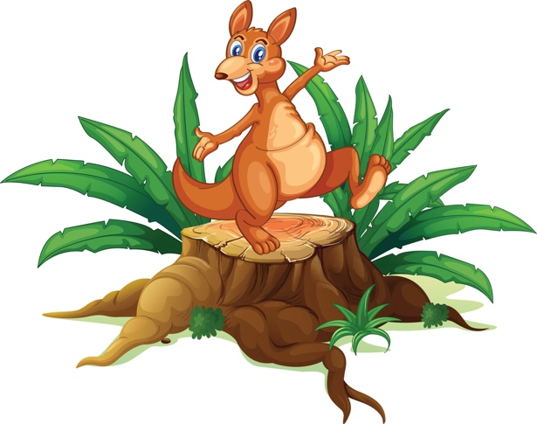
Feed the Elephant
- On a piece of cardboard about 20” square, draw a 10” circle in the center. This is the elephant’s head.
- Draw in large ears and a trunk extending out to one side.
- At the end of the trunk, make a hole large enough to hold a small funnel.
- Tape the funnel in place from the back, then hang your “elephant” on the wall.
- Each player is given five peanuts to toss into the elephant’s trunk.
- Play as teams or individuals.

First Aid Hike
Prior to the adventure, the leader discreetly “hides” several different items that one would find in a first aid kit – water bottle, baggie filled with band-aids, small bottle of antiseptic solution or container of wipes, etc…As the Scouts walk along the path, have them discover the different items and discuss how and when each is used. At the end of the hike, have each Scout make their own take-along first aid kit from the supplies that were found along the trail. End with a discussion of why having a first aid kit handy is a good thing. Especially in the jungle.

Loose at the Zoo
Prepare cutouts of different zoo animals from magazines, coloring books, or pictures you can draw or get from clipart.
Glue each cutout to an index card.
Make one animal card for each player.
Mark two parallel lines with chalk or rope 20 feet or more apart.
Select one player to be the zoo keeper. The rest of the Cub Scouts are the zoo animals.
Give each of the zoo animals an index card with the animal they will pretend to be in the game. Zoo animals hide their identity from the zoo keeper.
The zoo keeper stands between the lines while the other players stand behind one of the lines.
The zoo keeper patrols the zoo (play area), walking back and forth between the lines, and making sure there are no animals loose in the zoo.
At the same time the zoo keeper must shout out the names of the different zoo animals.
Players whose cards match the animal names called out must run to the opposite side of the play area before the zoo keeper tags them.
Any Cub Scout who is tagged must freeze instantly. Other Cub Scouts run around the frozen animals. Any Cub Scouts who make it across stand at the line for the next round. The game is over when all the animals are frozen. The very last zoo animal to get caught is the winner and becomes the zookeeper for the next round.
Creative options-
- For added fun, make a bunch of extra index cards with different animals on them. The Cub Scouts who make it across can become a new animal right away and continue playing.
- Instead of having the Cub Scouts who were tagged freeze, let them become assistant zoo keepers and try and help tag the animals that are still free.
Journey Through the Lion’s Den
- Choose a Scout to be a lookout tower.
- Half of the group are napping lions. The other half is a team of explorers.
- The “lions” are placed randomly around the room. The teams of explorers form lines and the Scout in front of the line is the tour guide. They are blindfolded (ask permission first) or they should close their eyes.
- The team members behind them may not make any sound or attempt to steer him.
- On signal, the “lookout tower” begins emitting a beeping sound in order to assist the tour guides in their path to safety at the lookout tower.
- The lions quietly make low snoring sounds, as they nap.
- The tour guides must find a path to the lookout tower without touching a “lion” (waking him).
- After the first round, encourage the Scouts to switch places.

Kim’s Game
Of course, you must play Kim’s Game, the ultimate scout “jungle” game from Baden Powell, based on his friend Rudyard Kipling’s Jungle Book. And it was in the first Scout Manual in 1908, so make it part of your 100th Anniversary of Scouting celebration. Here are the original game directions from B-P:
Place about twenty or thirty small articles on a tray, or on the table or floor, such as two or three different kinds of buttons, pencils, corks, rags, nuts, stones, knives, string, photos - anything you can find - cover them over with a cloth or a coat.
Make a list of these, and make a column opposite the list for each Cub Scout's replies.
Then uncover the articles for one minute by your watch, or while you count sixty at the rate of "quick march." Then cover them over again.
Take each Cub Scout separately and let them whisper to you each of the articles that they can remember, and mark it off on your scoring sheet.
The Cub Scout who remembers the greatest number wins the game.

Into the Jungle
- Cub Scouts are blindfolded, then told to hang on to a rope as they travel through the dark understory of the “jungle,” while an adult reads off a description of the route.
- Include things like: “Quick, duck there’s a snake in that tree!”
- To make it even more fun, set up an obstacle course in another room beforehand.
- Or divide the Cub Scouts into two teams – one gets to watch while the other explores.
- Then change places.

Lions and Tigers and Bears, Oh My!
Blow up several yellow, orange and brown balloons.
Scatter them all over the floor.
The Cub Scouts must go on safari and try to sort the animals out and put them in separate corners.
Try different rules:
Blowing only, no hands;
Using hands only;
Using feet;
Using a feather.

Monkey, Monkey, Tiger
The students sit in a circle and play this variation of "Duck, Duck, Goose." Great fun!

Outdoor Nature Hunt
Directions
- Make up a list such as the one below for each Cub Scout.
- Cub Scouts can hunt in pairs in your backyard or in the park.
- See which pair can find the most within a limited amount of time.
- A sample list: Something alive that flies, cup of wet sand, worm, cup of pink water Five maple leaves, 3 rocks at least two inches in diameter, piece of string, dandelion

Rhinoceros River Crossing
- One Scout plays a safari photographer and one Scout plays a rhinoceros.
- The other Scouts form a circle around the two players, leaving enough space between each Scout for the “rhinoceros” to pass through.
- When the game starts, all the Scouts in the circle must close their eyes. They are rocks in a river and the rhinoceros is trying to safely cross the river so they won’t have their picture taken by the photographer.
- Once the “rocks” have their eyes closed, the photographer starts counting to ten. As they do so, the rhinoceros tries to slip between the rocks to the safety of the other side of the river.
- Anyone who hears the rhinoceros make a sound may point to where they think the rhinoceros is, but must continue to keep their eyes closed.
- If the photographer says the direction is correct, the rhinoceros must take a place in the circle of rocks. The Scout who guessed correctly becomes the photographer who counts to ten, and the photographer becomes the rhinoceros.
- If the rhinoceros succeeds in escaping to the other side if the river without getting their picture taken, they come back to the middle of the circle and continues to act as the rhinoceros until they are “caught” (slips on a rock).

Sealed Envelope Contest
Give each person a sealed envelope with a blank 8 1/2 x 11 sheet of paper folded inside. The Cubs are told they are to write their names on the envelope, then open it and make a design or figure out of the paper by folding and tearing it. Time it for 5 or 10 minutes. Then they are asked to put their figures back in the envelope and hand them in for judging. The prize is given not for the paper design or figure, but to the Cub who opened their sealed envelope in the neatest manner!

Safari Hat Mania
- This is the same idea as musical chairs.
- Place Safari Hats in the middle of the floor.
- Play some music, turn off the music and everyone dashes to put a hat on their head.
- Have one less hat than kids so someone will not get a hat.
- Take out one hat each round until you have a winner.

Safari Relay 1
- Divide Scouts into two or three teams, depending on size, and put in lines. At a pack meeting, consider more teams.
- Each Scout in line is given the name of an animal that might be found in a jungle (if you’re first in line, you’re a tiger; second in line is a monkey, etc..).
- At signal, the first Scouts in the lines act like the animal they were assigned and try to travel a designated distance and return. Scouts can hop, crawl, run, pretend to fly, as long as that is the way the animal would travel.
- When the first Scouts return, the second Scouts act like their assigned animals to travel the distance and return.
- The game continues until all the Scouts have participated.
- The first team to finish wins.

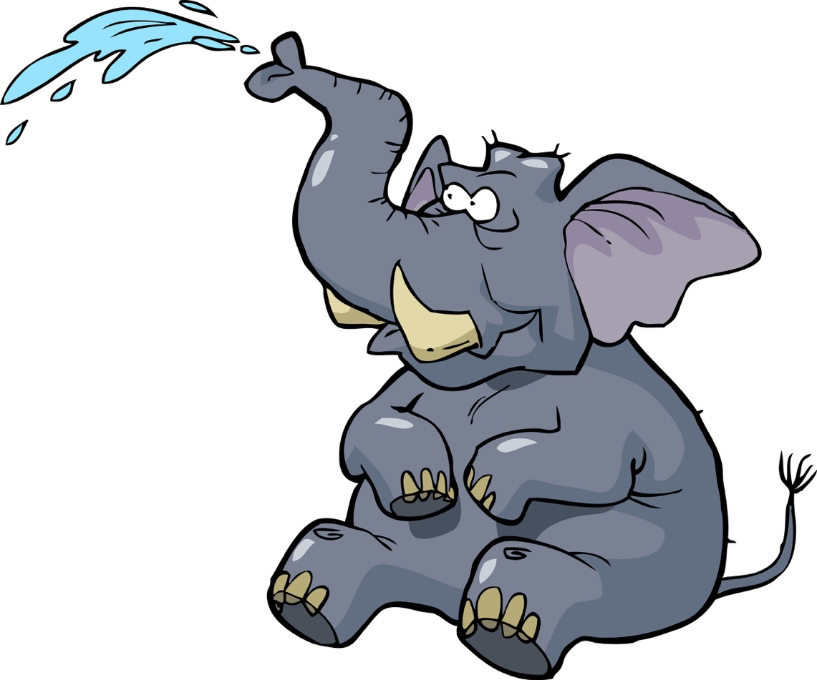
Safari Relay 2
- Prepare a set of cards ahead of time, listing different animals and describing their movement and/or sounds.
- Before the game begins, let Cub Scouts demonstrate each animal’s movement and sounds.
- Divide into two teams.
- Den chief or den leader stands at the opposite side of the room with a bag filled with a set of cards.
- First Cub Scout in each line races to the bag, chooses a card, then races back to the team moving and sounding like the animal whose card they drew.
- The next Cub Scout in line must guess what animal they are, then it’s their turn to race to the other side and choose a card.
- First team with each person done wins.

Suggestions for actions:
Lion – raise hands up in front of face, make clawing motions and growling;
Kangaroo – hops back to start;
Monkey – scratches under arms and makes monkey sounds all the way back;
Elephant – bend over with one arm out in front and waving from side to side;
Crocodile – slithers along the floor on all fours, close to the ground and swaying from side to side;
Boa – slithers along floor, stopping to twist body around three times as if squeezing something
See how many animals and actions the Cub Scouts can come up with!

Safari Slurp Game
Place animal crackers/cookies in a pile beside a small bowl.
- Have straws available for each player, along with a stopwatch, or a watch with a second hand.
- Using the straw as a vacuum, each contestant tries to pick up the animals and drop them into the bowl.
- The student with the fastest time wins.
Waiter, There’s a Monkey in My Soup!
Materials: A brown balloon and a paper plate for each player, permanent markers.
- Give each Cub Scout a blown up balloon. Using the markers, have them decorate them to look like monkeys. Let dry.
- Create start and finish lines.
- Divide the group into teams.
- Line the teams up relay style.
- The first Cub Scout races to the finish line and back, keeping their air-monkey perched on a paper plate.
- He must hold the plate waiter-style, with the arm up and the wrist cocked back.
- If the balloon sails to the ground, the Cub Scout must pick it up, put it back on their plate, and finish their leg of the relay by walking backwards.
- Before each team member starts their leg, their whole team must yell out, “Waiter, there’s a monkey in my soup!”
- This continues until each member of the team has had a turn.

Water the Elephants
This game is best played outdoors.
- Divide the group into two teams, and equip each team with paper cups.
- On a signal, the first person on each team dips their cup into a tub of water and races to a large empty soda bottle at the finish line.
- The Cub Scouts must fill the bottle with water from their cups.
- The first team to fill their bottle wins.

CLOSING CEREMONIES

Another Adventure Closing
Setting – 9 Cub Scouts; each with a letter from the word A-D-V-E-N-T-U-R-E on front (Recycle the A-D-V-E-N-T-U-R-E cards from the opening, if you can). Add on the back the letters G-O-O-D N-I-G-H-T. Cub Scouts may need a nudge with their verses. Have them handy, but so they can’t be seen when the cards are flipped to say Good Night.
Scene – Scouts in a line, or come in one by one and form a line.
#1: A - All of us had a great time tonight at our pack meeting. It was fun to
#2: D - Discover some cool new games and that great song.
#3: V - Very soon, our pack meeting will end and we will head home.
#4: E - Expeditions, like the one we were on tonight, bring
#5: N - New worlds to explore and new friends to find.
#6: T - The Cub Scout Promise also encourages
#7: U - Us to continue exploring and helping others by doing our best.
#8: R - Remembering to follow Akela will help us to live by our promise.
#9: E - Each of us has a special message to deliver tonight –
All: (Cub Scouts all flip cards and say together) GOOD NIGHT!

Back to Nature Closing Ceremony
Personnel - Cubmaster (CM) and four Cub Scouts
CM: Our pack meeting tonight brought us all together to think about nature. We can enjoy the great outdoors, but we must think of others who will follow us. Wherever you go in this great wide world of nature, try to be a “good” visitor who will leave the plants and the creatures undisturbed for others to enjoy after you leave.
#1: The only shots I took were snapshots.
#2: I try to walk on the pathways to keep off the plants.
#3: When I see animals or birds, I remember that I am a guest in their living place, and I don’t do anything to them except watch and observe.
#4: The one big thing I always do when I am ready to go home is to look and see that all the fires are out.
CM: With Cub Scouts like you to help keep your friends on the ball, I’m sure that the beauties of nature will be around for years to come.

Closing Ceremony

Camp Director: We have returned from a safari, and have learned much about the jungles and the animals in them. Let us share with you our knowledge.

Bobcat: I have gained appreciation for God, and His creations.

Tiger: I have studied the world we live in and the animals that roam upon it.

Wolf: I have found the enjoyment of freedom to explore, and learn of the animals and their homes.

Bear: I have learned to respect others as we worked together to learn about the jungles.

Webelos: I have found fun in camp as we traveled together helping one another.

Camp Director: The Cub Scouts have told how they have put into practice the Cub Scout Promise. Will you all please stand and repeat with me the Scout Law.

Cub Scout Safari Closing
(This should be done with the Safari opening)
Equipment:
- Two galleries - These can be placed on a chalk board, wall, boxes, or whatever else will work with the room arrangement that you have. The galleries will be on display throughout the meeting.
- Framed pictures of the animals mentioned in the opening and closing ceremonies. The den leader could have the Cub Scouts draw the pictures from books during den meeting and put the pictures in simple paper frames. Two frames that have the word "NEXT" in them, pins or tape to hang the pictures in the gallery.
Personnel: Narrator, Cub Scouts
Narrator: We can save animals, if we really want to. The animals we will show you now are living proof of what people can do. All were headed for extinction when people stepped in to save them. (The Cubs now show their pictures and read the details of each animal after saying it's name.)
#1: Bald Eagles were listed as “endangered” in 1967, after hunting, poisoning and use of DDT reduced the number of bald eagles to 417 breeding pairs in the United States. Today, there are over 10,000 breeding pairs of bald eagles across Alaska and the lower 48 states.
#2: White tailed Gnu: More than 4000 are alive in South Africa
#3: Bontebok: Sixty years ago, fewer than 100 of these antelopes were living in Africa. Now there are 1,000.
#4: Mongolian Wild Horse: Extinct in the wild, these beautiful horses have been kept alive in zoos. There are now over 1,000 of them in zoos around the world.
#5: Giant Panda: Protected from habitat destruction by a large preserve in China.
#6: American Alligator: A big success! More than 800,000 are now living in the United States.
#7: American Bison: In 1903, fewer than 100 survived. There are now more than 80,000

Nature and the Good Visitor Closing
Committee Chairman: Our Pack meeting tonight brought us all together to think about nature. We can enjoy the great outdoors but we think of others who will follow us. Wherever you go in the great wide world of nature, try to be a "good" visitor who will leave the plants and the creatures for others to enjoy after you leave.
#1: The only shots I took were snapshots.
#2: I tried to walk on pathways to keep off plants.
#3: When I see animals or birds, I try to remember that I am a guest in their living place and I don't do anything to them but look at them.
#4: The one big thing I always do when I am ready to go home is to look and see that all fires are out in nature's backyard.
Cubmaster: With Cubs and Webelos like you to help keep our friends on the ball, I'm sure that the beauties of nature will be around for years to come. Thanks Cubs, Good Night.

What We Learn from the Jungle Closing

Props: Have each Cub Scout choose one of the animals below, and draw the animal on a big piece of construction paper or poster board. Color or paint it, cut it out, and stick their words on the back.

Leader: This camp’s theme was “Jungle Safari” - let’s see what the Cub Scouts learned from the jungle.

Rhinoceros: “From the Rhinoceros we learn to charge through obstacles that stop us.”

Panther: “From the panther we learn strength and speed, to guide us on our way.”

Cobra: “From the Cobra we learn not to bite off more than we can chew.”

Monkey: “From the monkey we learn to be tricky and cunning, and use our brain.”

Elephant: “From the elephant we learn not to forget our friends, and those who help us.”

All: “We had a jungle of fun at camp!”

Wildlife Pledge Closing
Provide copies of the "Wildlife Pledge" below to each person or pair in the audience, and ask them to repeat it together.

I pledge to use my eyes to see the beauty of all outdoors.
I pledge to train my mind to learn the importance of nature.
I pledge to use my hands to help protect our soil, water woods and wildlife.
And by my good example, show others how to respect, properly use, and enjoy our natural resources.

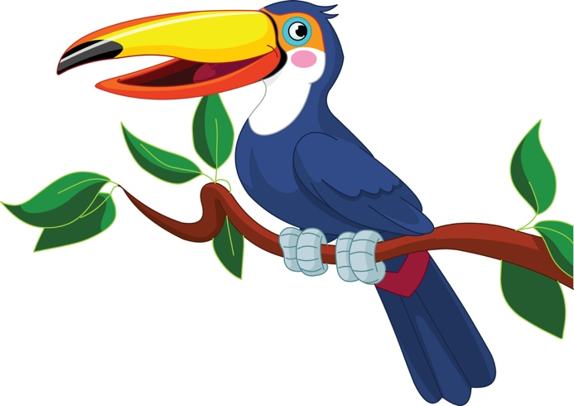

CUBMASTER MINUTE

Binocular

Materials: Binoculars, Camp Director (dressed as a Safari Guide)

Did you know that you can look through either end of a pair of binoculars? (Look through the wrong end). If you look this way, everything is very tiny and distant. You don’t see things the way they should be seen. The binoculars make the view look worse instead of better. (Turn the binoculars the right way). But if you use them the right way you see things as they are supposed to be seen. In fact, you even get a better perspective of how things look, things look closer and clearer. As we close this week of Jungle Adventure Day Camp into the wilds of Cub Scouting think about how you look at achievements and badges, people and things in everyday life. Do you see them distorted and distant or do you see them in the best possible light? Remember to "Look well, o wolves", and "Do your best"!

Be A Giraffe!
The giraffe can teach us a lot about Responsibility. First of all, it stands tall – and when the giraffe is out on the African plains, there’s no doubt where they stand. Each of us should also stand tall, and make sure that whatever we do is something we can be proud of – so stand tall! The giraffe is adaptable – willing to bend their long neck and stretch out their legs when they need water. So be willing to bend - to adapt to change or follow a needed “Plan B.” The giraffe is willing to stick their neck out to accomplish something – like eating the best leaves high in the tree. And we should also be willing to stick our necks out - to reach the highest goals and take responsibility for all that we do. So be a giraffe!
Jungles and Computers
This month you traveled in the jungles here and around the world by computers and books. Your eyes were opened to see many wonderful things. Now continue on your journey in the World of Scouting. Akela and the pack will help you on your way with cheery calls of "Good Scouting." Hopefully, you will never forget your days in the jungle with the pack, and one day, may you return and help other cubs open their eyes to the wonderful things in the jungle.
Good Night and Good Scouting.

Jungle Book
One of the very first things you learned as a Bobcat was the story of Mowgli, the boy adopted by the wolf pack. When he came to Council Rock to become a member of the pack he agreed to learn and follow the Scout Oath. Akela was the wise old wolf, the leader of the pack. Their duty was to see that all the young Cub Scouts keep the Scout Law. Today at our camp, we know that Akela is any good leader, teacher or parent who helps Cub Scouts learn to be strong and useful. When the wolf camp met in the jungle, Akela, the Old Wolf, stood on a great rock in the middle and the camp sat in a circle round it. Today many Day Camps form a circle around Akela when he calls them together for the Grand Howl or for a talk. For this reason the circle is a common formation for camps and packs the world over and also because the circle is a sign of family unity. Let us now form our family circle and give the Grand Howl as we close our camp.

Jungle Closing
You have wandered through the Jungle and your eyes have been opened to see many wonderful things. Now you go
forward on your journey into the greater land of Scouting, and Akela and the pack speed you on your way with a cheery call of 'good hunting." You will never forget your days with the pack, one day, it may be that you will return to it and help other cubs to open their eyes in the jungle. Good Hunting.
Lord Baden-Powell

Nature

During our camp, we have learned about animals, big and small. The Cub Scouts explored the worlds of mammals, birds, marsupials, reptiles, insects, fish, and more. They have learned fascinating facts about them and I am sure have developed an appreciation for them. As the Cub Scouts have found, you don’t have to go far to learn about animals. You can go on a “safari adventure” in your own back yard, a nearby park, the woods and fields, and on a country road. Continue exploring and you will find many wonderful things that we have been given to enjoy.

THEME RELATED

Fun Facts About the Jungle
Jungle usually refers to a dense forest in a hot climate, such as a tropical rainforest.
The word jungle originates from the Sanskrit word jangala which refers to uncultivated land
All rain forests are jungles, but not all jungles are rain forests.
About 6% of the Earth's land mass consists of the ecosystems that could be called a jungle.
About 57% of all species live in jungle environments.
About 25% of all medicines come from the rain forests.
More than two thirds of the world's plant species are found in the tropical rainforests: plants that provide shelter and food for rainforest animals as well as taking part in the gas exchanges which provide much of the world's oxygen supply.
Central Africa holds the world's second largest rainforest.
The rainforests of Asia stretch from India and Burma in the west to Malaysia and the islands of Java and Borneo in the east.
Bangladesh has the largest area of mangrove forests in the world.
Some rainforest plants, like orchids, have flowers with colors and/or smells to attract insects.
Because there is little light or food on the jungle floor, many plants live on the branches of other plants, or even strangle large trees to fight for survival.
The humidity of the rainforest allows some plants to have aerial “roots” and feed on the air itself.
It is so humid in the jungle that decomposition of plant materials takes only a tenth the time.

Bromeliads, which grow on the jungle floor, are related to pineapples – they catch and hold rainwater. Several small beetles, crane flies, earwigs, a frog, a cockroach, spiders, fly larvae, a millipede, a scorpion, woodlice and an earthworm were all found living in one bromeliad!
Rain forest vines, called lianas, link trees to each other and animals use them to move from tree to tree.
Every second, we are losing 1-1/2 acres of rainforest to “slash and burn.”
Every day, we are losing 137 species of plant, animal and insect species.
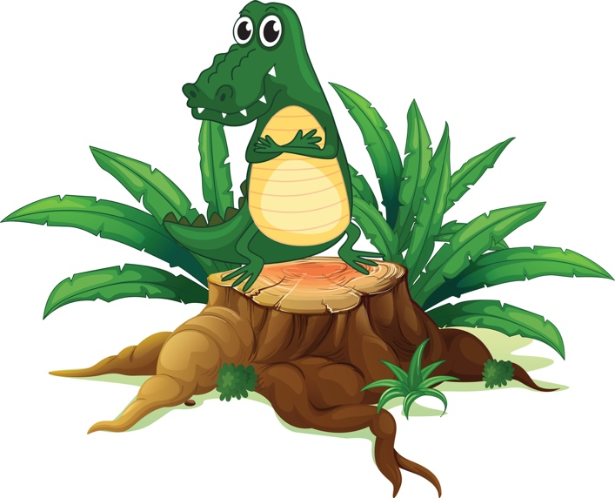
Fun Connections Between Baden-Powell
and Rudyard Kipling
Both men were authors – Kipling wrote 4 novels as well as his many poems and children’s stories; but Baden Powell authored 36 books, numerous scouting booklets, and a weekly “yarn” in the scouting magazine.
The term "The Law of the Jungle" is drawn from Rudyard Kipling's The Jungle Book and referred to an intricate code of laws for the animals.
Rudyard Kipling wrote the Jungle Books while living in Brattleboro, Vermont on an estate belonging to his wife’s family.
Rudyard Kipling was a friend of Baden-Powell, and wrote the first official scout song.
Kipling was also made a “Commissioner for Scouts” – he gave instructions for how to do the Grand Howl – an early applause used by huge groups of scouts.
Both men were the sons of clergymen, who also authored books.
Both men experienced jungles in India and Africa, with their different plants and animals.
Both men were born in the Victorian era, when the British empire extended across the world and included both India and large parts of Africa.
Both men had fathers who were talented artists with pen and ink, and inherited their abilities. In fact, Kipling’s father illustrated some of his stories, and pioneered art education in India.
Both men illustrated many of their stories and books – and BP could use either hand – in fact, he sometimes used both hands at once! Although Kipling was not in Africa at the time of the 217 day siege of Mafeking with Baden-Powell, he wrote many poems in support of the troops, including “South to Table Bay” – and BP regularly told Kipling stories to boost morale in Mafeking.
Kipling usually didn’t allow anyone to use his stories – but he gladly gave permission for his friend BP to adapt the Jungle Book to use with the new “Cub Scouting” organization.
Winston Churchill wrote about both men in glowing terms; they each received honorary degrees, and both men hated the notoriety of fame.
Both men were nominated for the Nobel Prize – Kipling actually was awarded the prize for literature in 1907 for his Jungle Books. Baden-Powell was nominated for the Peace Prize in for his work in 1938 and the preceding thirty years in promoting the “fraternity of the nations…through the Boy Scout Movement.” Unfortunately, because of WWI, the Peace Prize was not awarded in 1939.
Both men loved motoring all over the country and both men owned a Rolls-Royce. The Scouts of the world gave BP his, and Kipling said it was the “only car he could afford” because of its longevity and reliability.”
Both men felt that smoking and drinking to excess were very damaging – BP felt the sense of smell was vital to a scout. Kipling was known for his keen sense of smell, and often referred to smells in his poetry.
Both men were offered burial in Westminster Abbey, a rare honor for a commoner. Baden-Powell chose to be buried in Nyeri, Kenya, Africa, but a memorial stone was placed in the Abbey near where Kipling is buried – so the two friends are still linked.

DECORATIONS

Decorations emphasize the theme and help set the mood. Theme-related music playing in the background also helps set the atmosphere. This month, make trees from brown paper bags by crushing them down and stacking them. Add green tissue paper for leaves. Decorate around the entry door, too. Place stuffed animals and hang pictures around the room. Play a sound track with sounds of monkeys and elephants for a real safari feel.

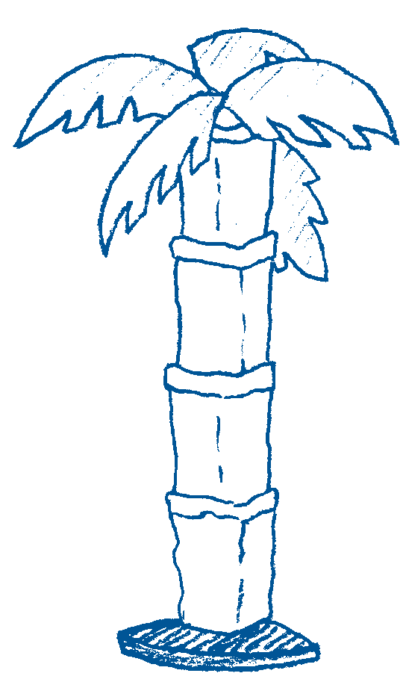
Create a Palm Tree
Materials: Brown paper bags, green construction paper, tape; tree base made from a lamp stand or a 5- to 6-foot dowel rod or PVC pipe secured in a bucket of plaster of Paris
Start with five brown paper bags. Cut a hole in the bottom of each bag. Slide over the tree base, setting one bag atop another. To sculpt the bags to resemble the trunk of a palm tree, fold the back part over upon itself and secure with tape. For palm fronds,
cut and notch oval shapes from green construction paper and tape to the top of the structure.
Place your paper bag trees on the stage area where awards will be presented
Alternate method: Wrap the pole or lamppost with brown paper and then draw hash marks to resemble the distinctive bark seen on trimmed palm trees.

Make a vine
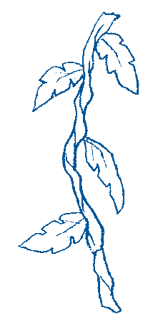
Cut brown paper bags into 3-inch strips. Crumple and twist the strips to form a 1-inch-diameter length resembling a vine’s woody stem. Attach lengths of crumpled strips end-to-end to make one or more long vines. Add leaves cut from construction paper. For authenticity, consult library books or other reference materials to copy the leaf shapes typically found on tropical vines.
Drape vines along the walls, across the ceiling, and above the greeting and refreshment areas. Decorate around the entrance door with vines and leaves. Source: www.pinterest.com/pin/AbS1oRApckoyHzCEEBby0k4Pai-QTAXoWp77lqbYQ965p1btIvIQwFY/
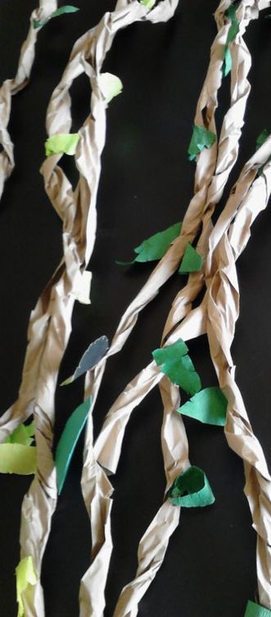
Paper Plate Safari Hats
Source: http://widgetworm.blogspot.com/2008/10/paper-plate-safari-hats.html
Materials: Vanity Fair plastic bowls and plates, hole punch, scissors, twine, spray paint, hot glue gun

Trace the shape of the bowl onto the plate and cut the hole slightly smaller. Hot glue them together. Add spray paint and twine.

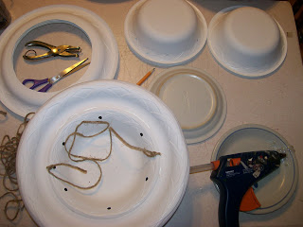

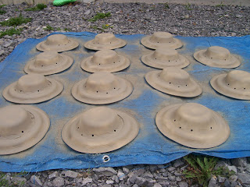

Binoculars
Instructions: www.pinterest.com/pin/71635450300028659/
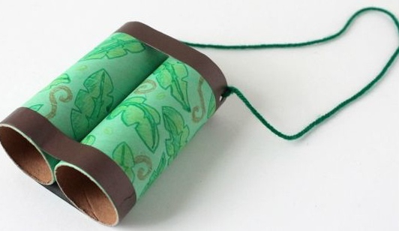

Souce: http://meandmyinsanity.com/2012/10/coffee-filter-lion-preschool-craft.html/toilet-paper-roll-binoculars-3882
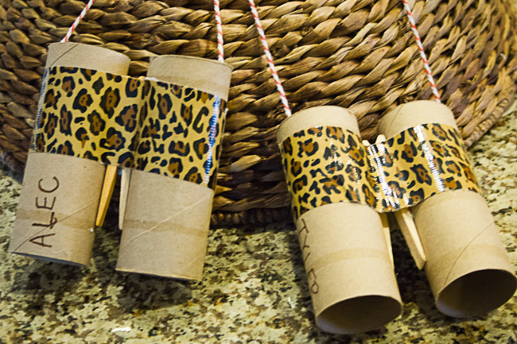

Jungle Themed Decoration Ideas
Source http://grassybranchfarms.blogspot.com/2013/05/camp-tarzan.html

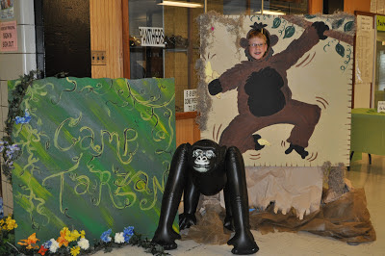

Source: http://catchmyparty.com/photos/1248642
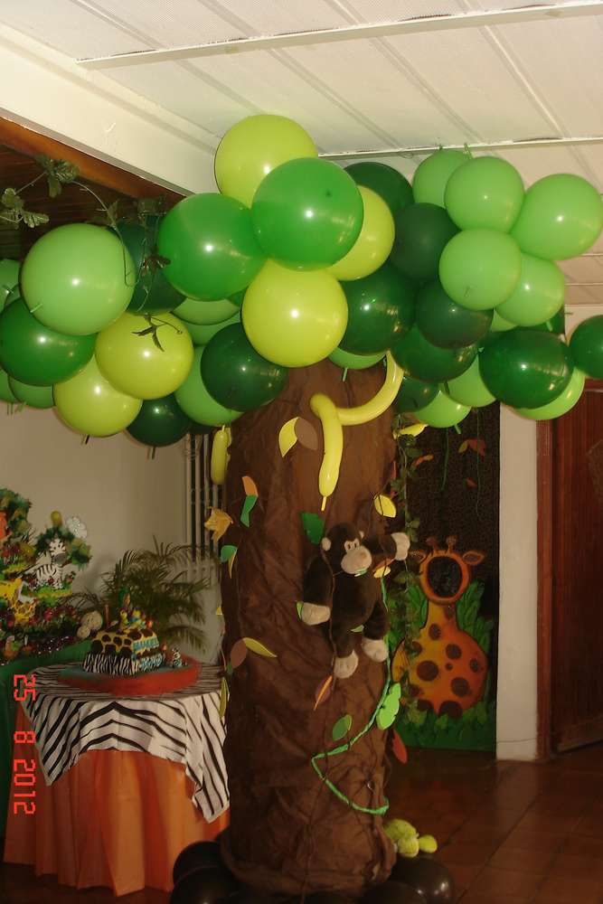
Source: https://www.pinterest.com/pin/213639576046426784/
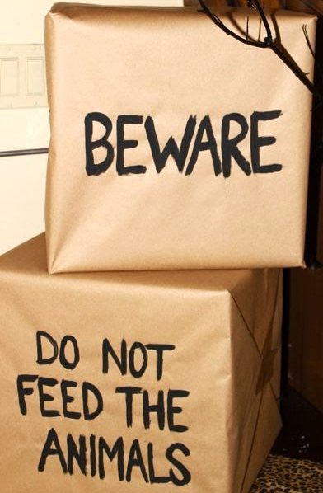

Jungle vines made from dollar store table cloths, cut into strips. www.pinterest.com/pin/514184482431919441/

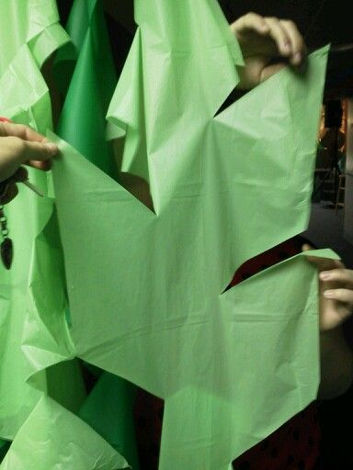
Source: www.pinterest.com/pin/107312403596995224/
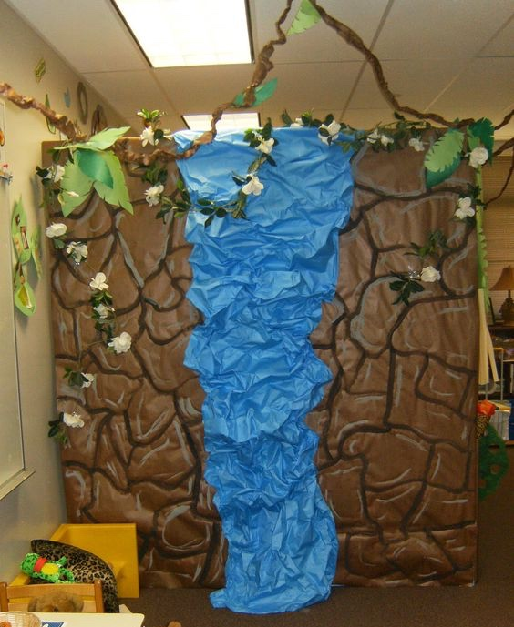
Source: www.pinterest.com/pin/534169205773820398/
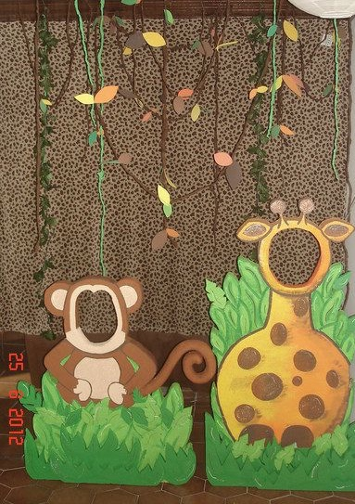

www.pinterest.com/pin/508977195368316953/

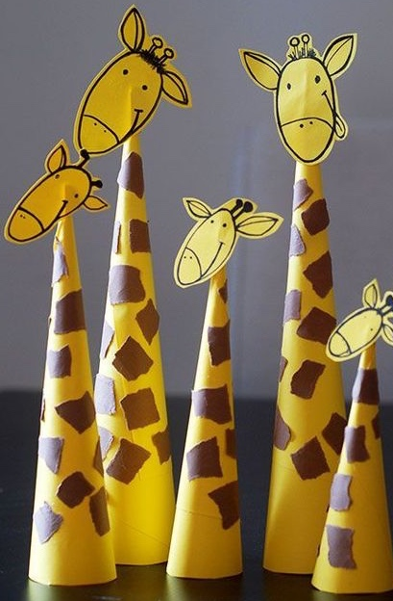

www.pinterest.com/pin/70437472304719/
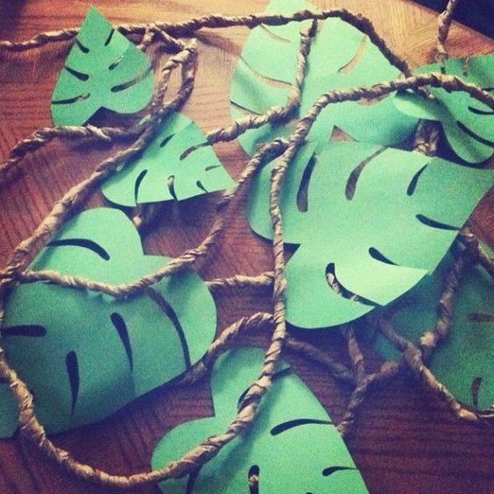

www.pinterest.com/pin/137430226109270728/
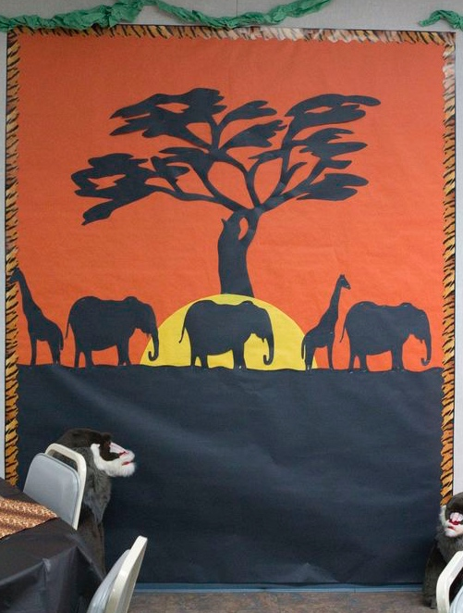

Source: www.pinterest.com/pin/371476669234257579/

Jungle Word Search

X | U | E | X | P | A | R | R | O | T | I | G | E | R | D
M | V | H | Q | A | L | L | I | R | O | G | O | Z | Z | R
D | T | J | W | G | E | P | S | I | A | J | V | S | J | X
T | U | S | C | H | E | E | T | A | H | E | M | I | H | H
K | L | T | Y | R | S | G | O | R | F | S | N | A | K | E
O | E | O | K | H | O | O | O | F | P | D | G | H | R | U
U | O | X | U | I | D | C | A | M | S | R | O | Q | W | R
X | P | R | C | N | D | R | O | A | D | A | F | S | E | R
C | A | O | A | O | I | N | P | D | R | Z | E | B | R | A
L | R | P | G | G | K | X | P | N | I | I | S | A | J | Z
Y | D | T | O | E | N | S | I | A | B | L | I | O | N | T
Y | E | C | Y | T | N | A | H | P | E | L | E | W | Q | D
N | C | Z | E | A | L | O | K | S | P | I | D | E | R | C
P | Y | L | B | S | R | A | E | B | T | O | H | M | E | W
E | C | D | X | O | W | M | U | H | J | W | R | G | Q | J

BEARS | BIRDS | CHEETAH | CROCODILE
ELEPHANT | FROGS | GIRAFFE | GORILLA
HIPPO | KANGAROO | KOLA | LEOPARD
LION | LIZARDS | MONKEY | PANDA
PARROT | RHINO | SNAKE | SPIDER
TIGER | ZEBRA

